# Home Page (About Me)

**Header: Bismah Tapal**

**Short Bio:**

**Hi, I’m Bismah Tapal.**

**I am a journalist, communications specialist, and digital storyteller with experience across newsrooms, nonprofit organizations, and advocacy campaigns in Canada, Pakistan, and the United Kingdom.**

**My work combines sharp editorial judgment with creative digital strategy. I have driven large-scale audience engagement through SEO-driven journalism and led communication initiatives that contributed to legislative change.**

**Currently based in London, I earned a Master’s in Media and Communications from Goldsmiths, University of London, where I developed advanced skills in multimedia production, data journalism, and digital storytelling.**

**  
Social Icons:** [**LinkedIn**](http://linkedin.com/in/) **|** [**Instagram**](https://www.instagram.com/bismahtapal/)

**Navigation Menu:**

* **Corporate Communications**
* **Social Media Management**
* **Journalism and Copywriting**
* **Contact Me**

# Corporate Communications Page

**Page Title: Corporate Communications**

**Short Description:**

**I specialize in developing strategic communications that drive real-world impact.**

**From legislative reports that influenced government policy to multi-stakeholder advocacy campaigns, my work in corporate communications combines research, storytelling, and visual presentation to engage audiences and push for change.**

**Gallery:**

1. **ACORN Canada’s year end report 2023 (**[**https://acorncanada.org/wp-content/uploads/2024/01/ACORN-Canada-2023-Year-End-Report-2-compressed.pdf**](https://acorncanada.org/wp-content/uploads/2024/01/ACORN-Canada-2023-Year-End-Report-2-compressed.pdf)**)**

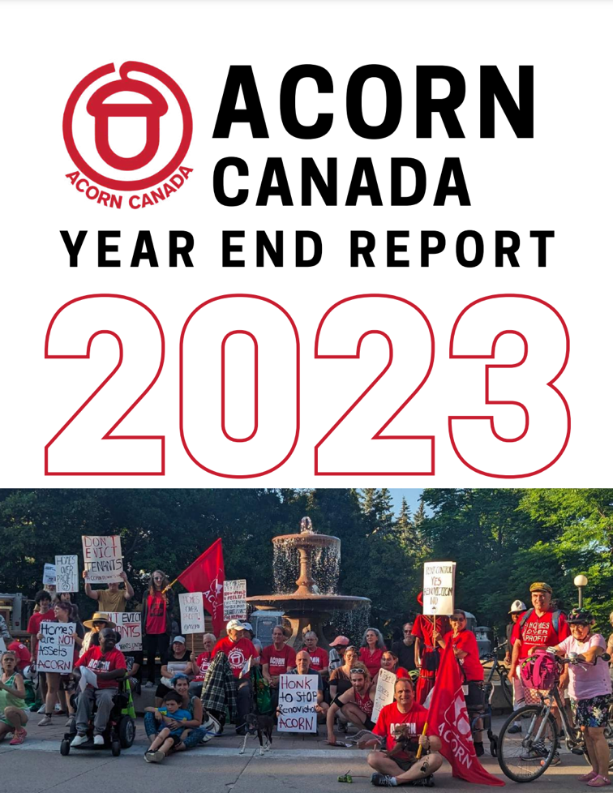

1. **Peel ACORN’s Mississauga tenant survey 2023 (**[**https://acorncanada.org/wp-content/uploads/2023/11/Peel-ACORN-Mississauga-Tenant-Survey-2023.pdf**](https://acorncanada.org/wp-content/uploads/2023/11/Peel-ACORN-Mississauga-Tenant-Survey-2023.pdf)**)**



1. **ACORN’s report on extreme heat and climate justice (**[**https://acorncanada.org/wp-content/uploads/2023/09/National-Extreme-Heat-Report-2023-1.pdf**](https://acorncanada.org/wp-content/uploads/2023/09/National-Extreme-Heat-Report-2023-1.pdf)**)**

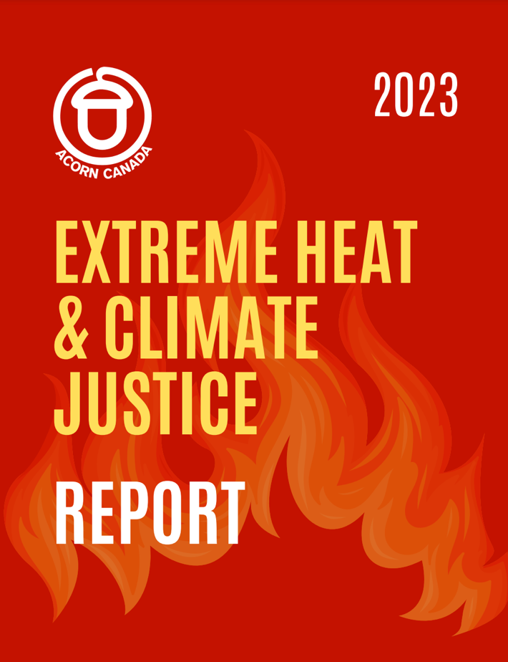

1. **ACORN International website (**[**https://acorninternational.org/**](https://acorninternational.org/)**)**

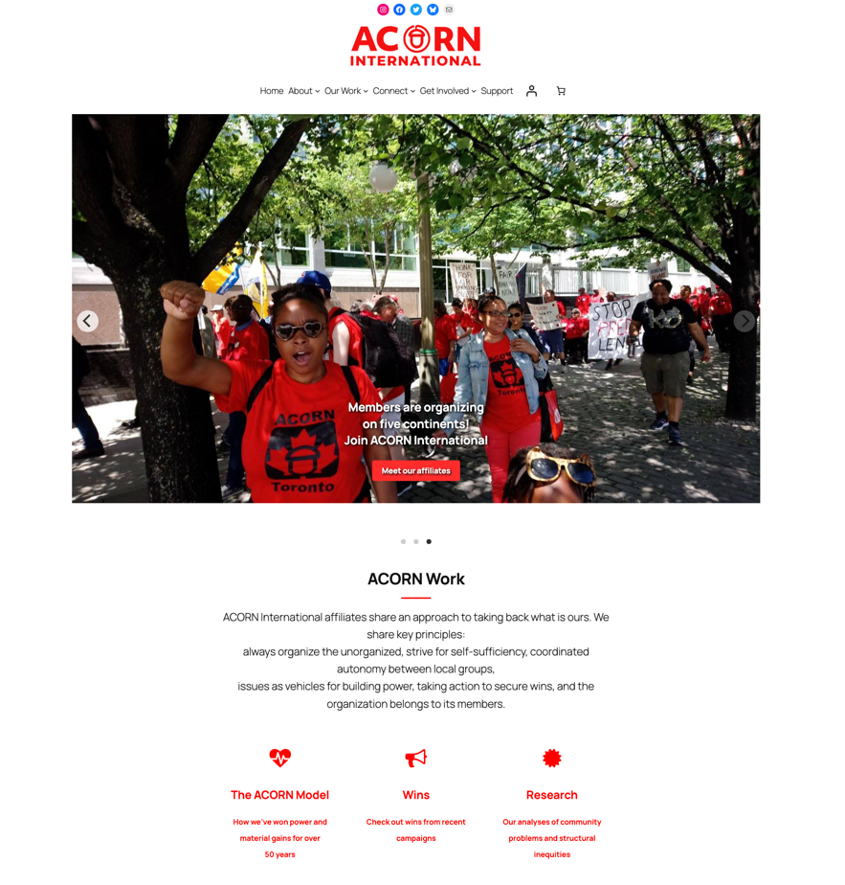

# Social Media Management Page

**Page Title: Social Media Management**

**Short Description:**

**I have managed and grown social media platforms for companies and nonprofits, creating engaging, strategic content across Instagram, LinkedIn, and Twitter.**

**My approach blends platform-specific creativity with data-driven optimization, ensuring content not only looks good but also delivers results.**

**Gallery:**

1. **@dawn_dot_com (**[**https://www.instagram.com/dawn_dot_com/**](https://www.instagram.com/dawn_dot_com/)**)**



1. **@dawn.today (**[**https://www.instagram.com/dawn.today/**](https://www.instagram.com/dawn.today/)**)**

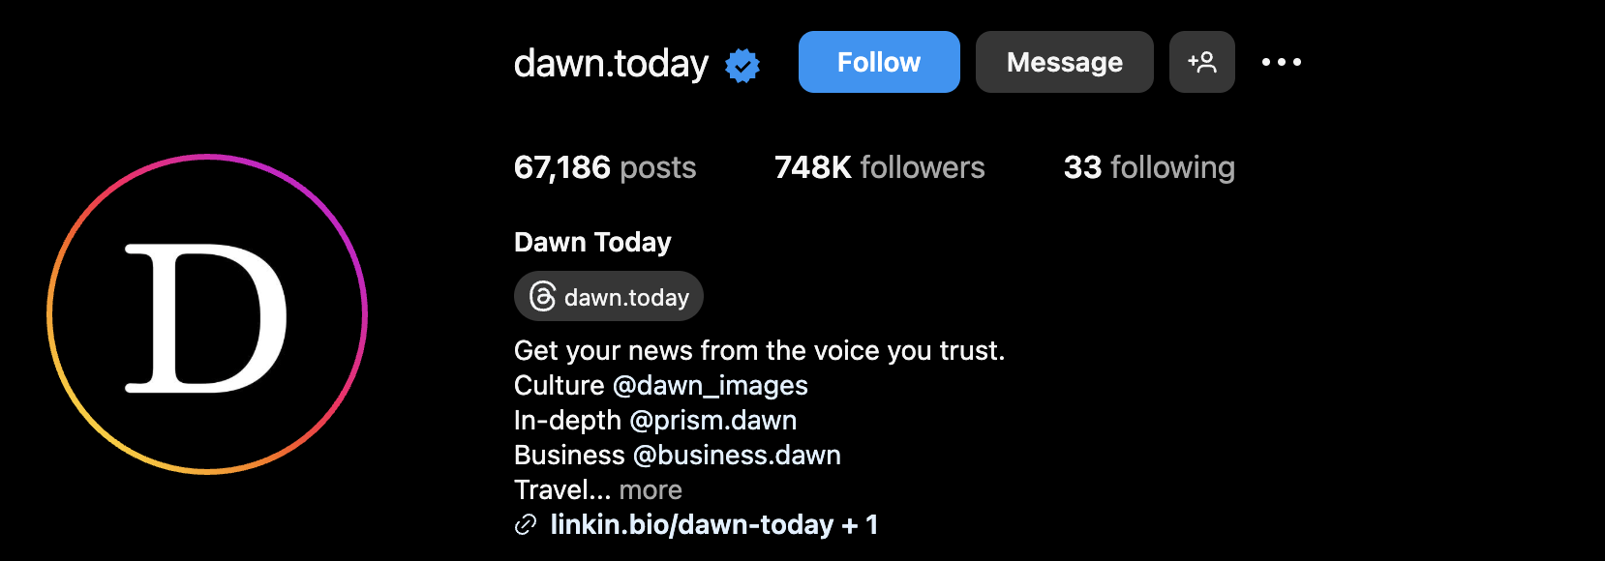

1. **@espressopk (**[**https://www.instagram.com/espressopk/**](https://www.instagram.com/espressopk/)**)**



1. **@chatterboxdeli (**[**https://www.instagram.com/chatterboxdeli/**](https://www.instagram.com/chatterboxdeli/)**)**

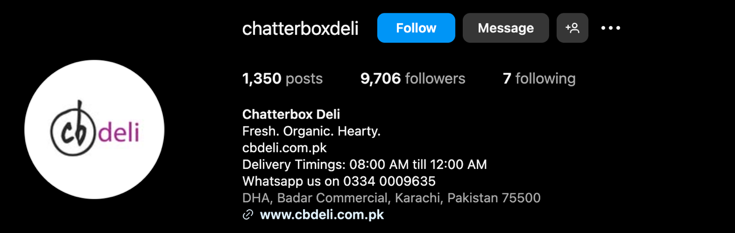

1. **@spotworkapp (**[**https://www.instagram.com/spotworkapp/**](https://www.instagram.com/spotworkapp/)**)**

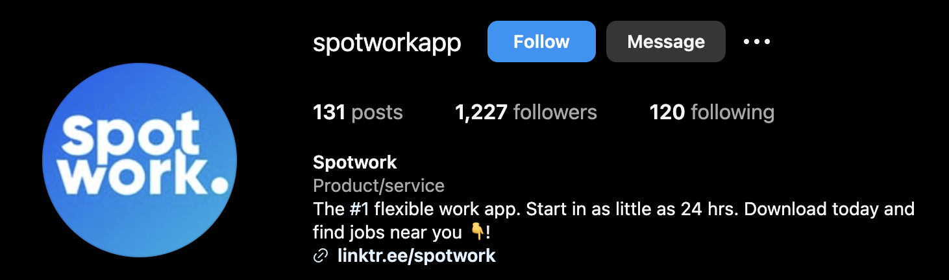

1. **@spotworkco (**[**https://www.linkedin.com/company/spotworkco/**](https://www.linkedin.com/company/spotworkco/)**)**

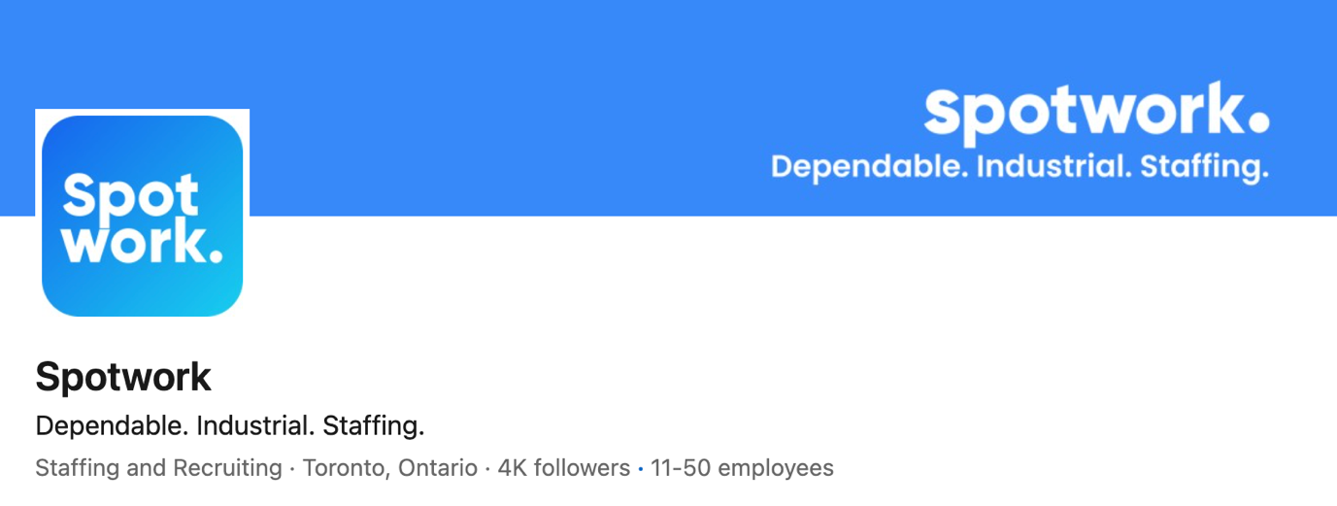

1. **@acorncanada (**[**https://www.instagram.com/acorncanada/**](https://www.instagram.com/acorncanada/)**)**

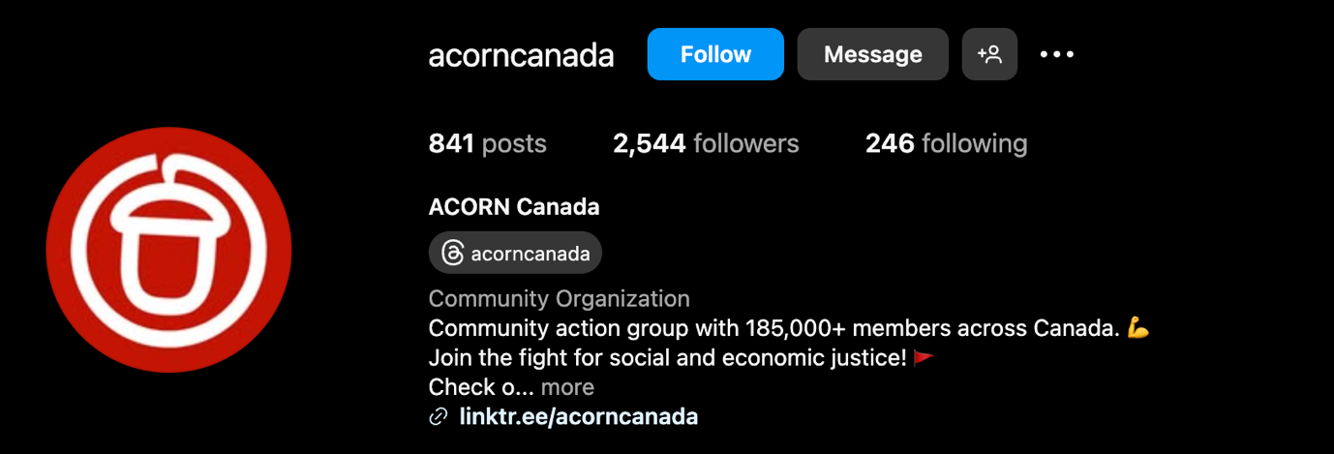

1. **@acorncanada (**[**https://x.com/ACORNCanada?ref_src=twsrc%5Egoogle%7Ctwcamp%5Eserp%7Ctwgr%5Eauthor**](https://x.com/ACORNCanada?ref_src=twsrc%5Egoogle%7Ctwcamp%5Eserp%7Ctwgr%5Eauthor)**)**

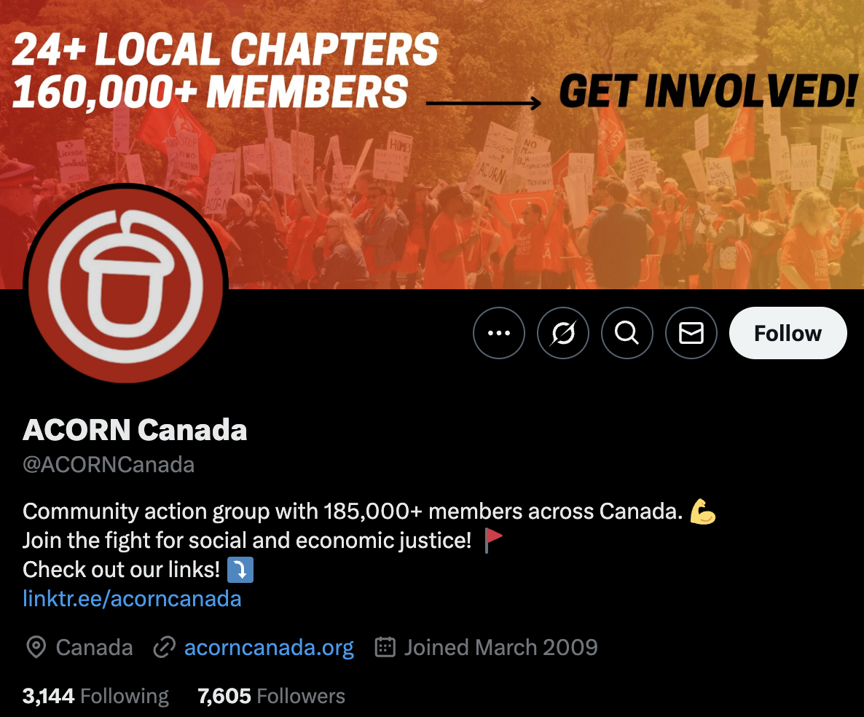

1. **@acorncanada (**[**https://www.facebook.com/acorncanada**](https://www.facebook.com/acorncanada)**)**

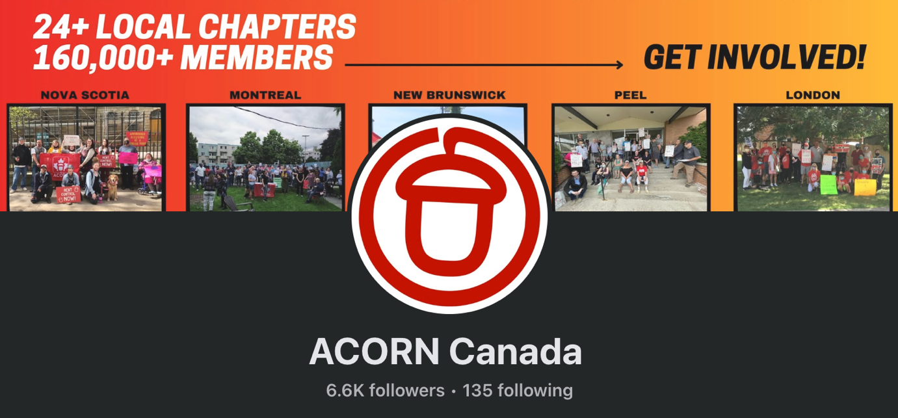

1. **@theexpresstribune**

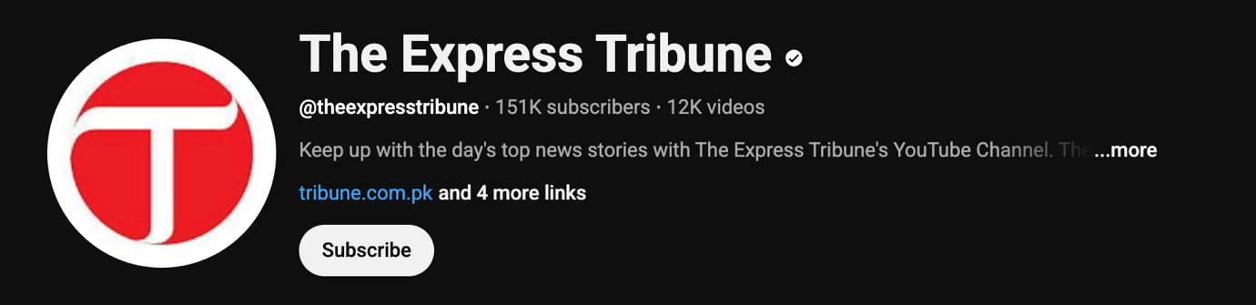

# Journalism and Copywriting Page

**Page Title: Journalism and Copywriting**

**Short Description:**

**As a journalist and copywriter, I have reported on global affairs, technology, business, and cultural stories for major publications like The Express Tribune and Dawn News.**

**Whether it’s breaking news, feature reporting, or creative advertising copy, I focus on producing sharp, compelling narratives that resonate.**

**Gallery:**

# **Pakistan’s silent suicide problem (**[**https://www.dawn.com/news/1494208**](https://www.dawn.com/news/1494208)**)**

**

# **Simone Biles' birth mom and estranged dad push to reconnect with Olympic star amid addiction battles (**[**https://tribune.com.pk/story/2487987/simone-biles-birth-mom-and-estranged-dad-push-to-reconnect-with-olympic-star-amid-addiction-battles**](https://tribune.com.pk/story/2487987/simone-biles-birth-mom-and-estranged-dad-push-to-reconnect-with-olympic-star-amid-addiction-battles)**)**

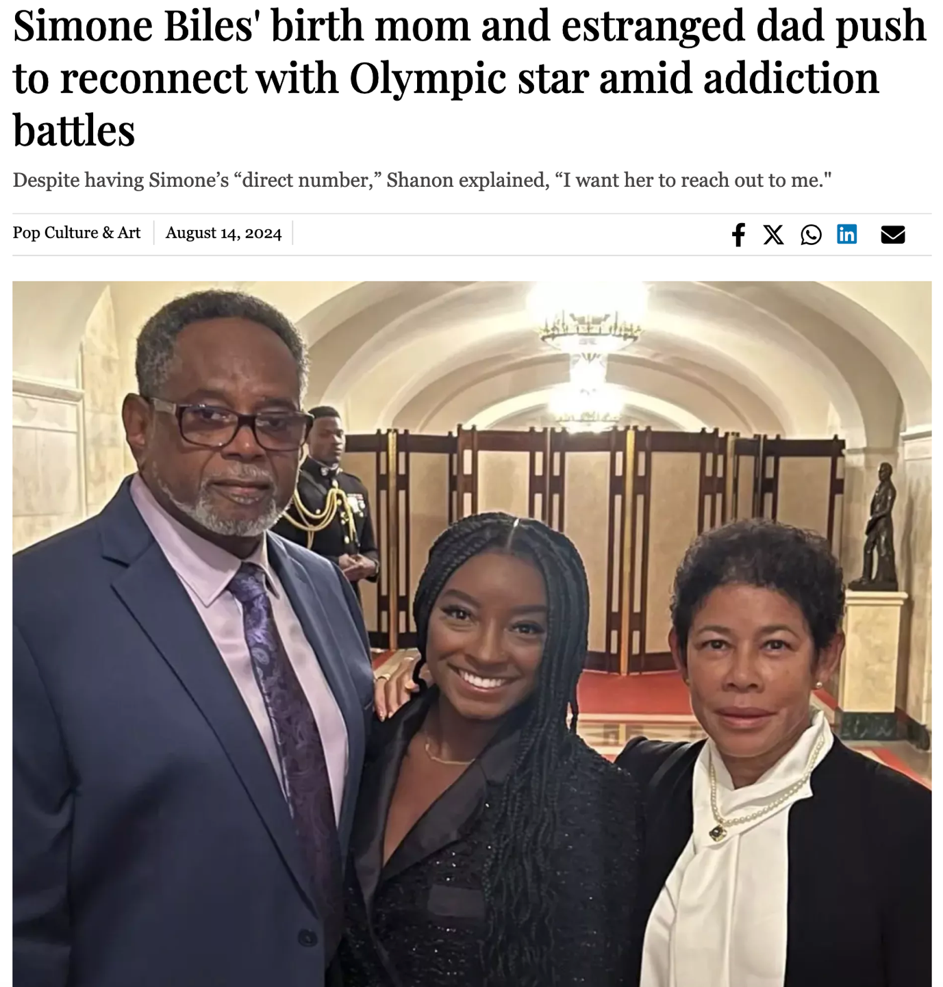

# **Toomaj Salehi: Iranian rapper sentenced to death (**[**https://tribune.com.pk/story/2464185/toomaj-salehi-iranian-rapper-sentenced-to-death**](https://tribune.com.pk/story/2464185/toomaj-salehi-iranian-rapper-sentenced-to-death)**)**

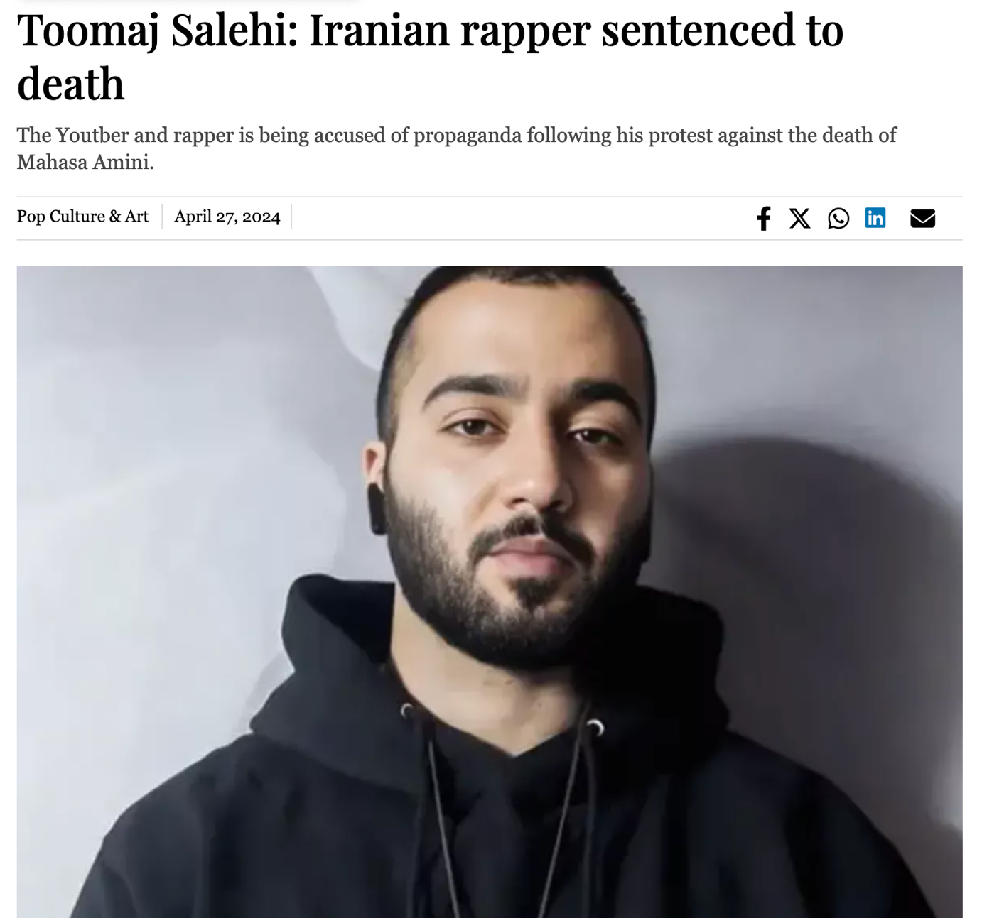

# **Kendrick Lamar-Whitney Alford: Unraveling allegations about the relationship (**[**https://tribune.com.pk/story/2465401/kendrick-lamar-whitney-alford-unraveling-allegations-about-the-relationship**](https://tribune.com.pk/story/2465401/kendrick-lamar-whitney-alford-unraveling-allegations-about-the-relationship)**)**

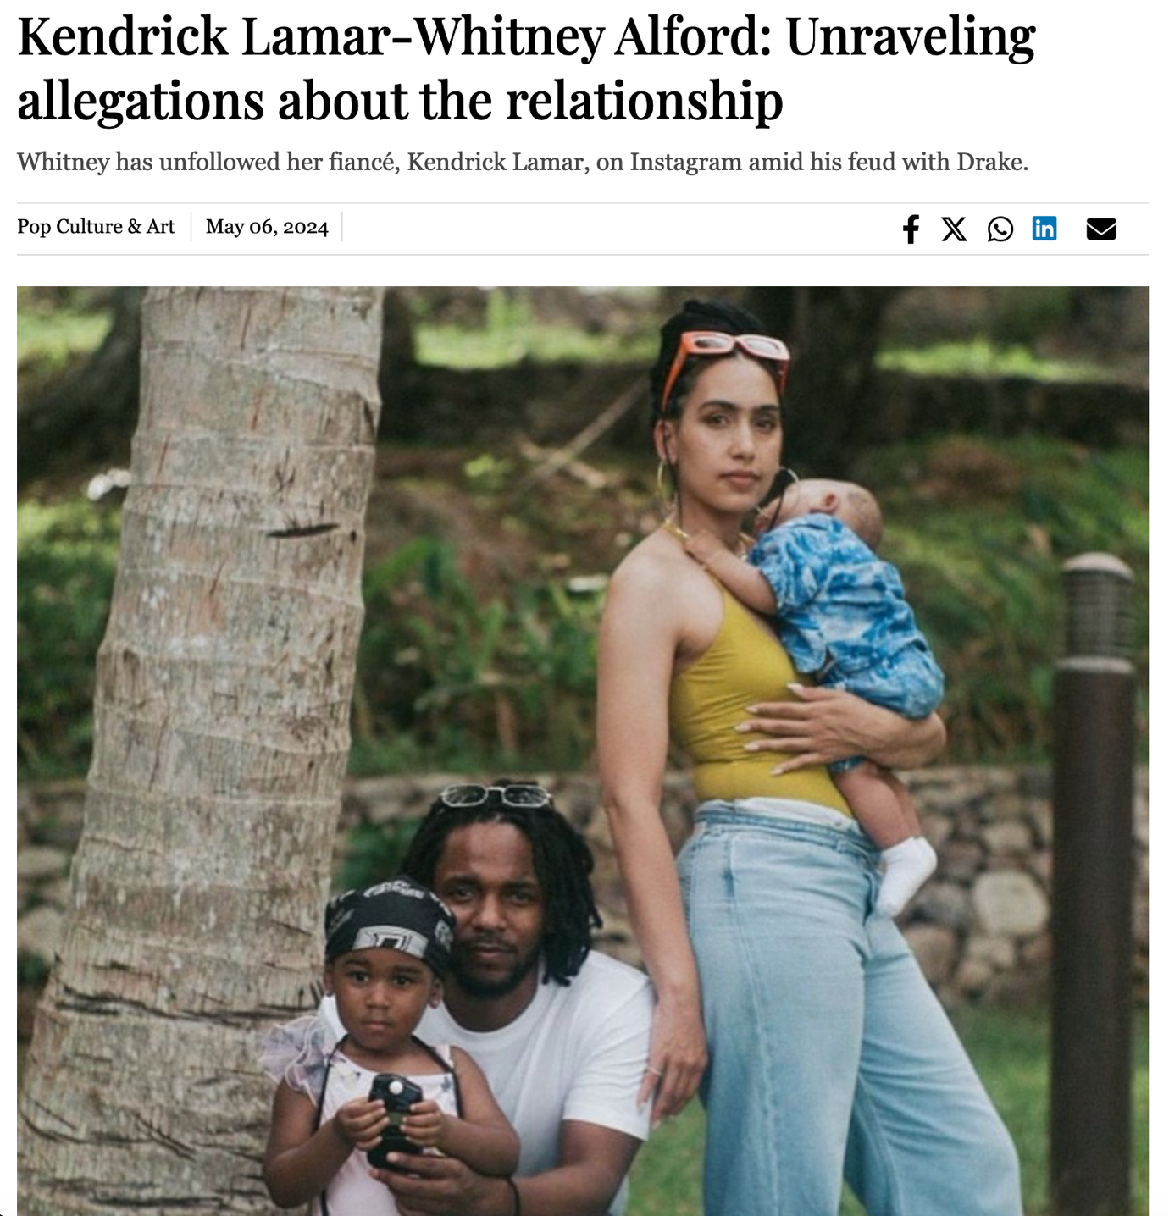

1. **Vienna celebrates 200 years of Beethoven's Symphony No. 9 (**[**https://tribune.com.pk/story/2465554/vienna-celebrates-200-years-of-beethovens-symphony-no-9**](https://tribune.com.pk/story/2465554/vienna-celebrates-200-years-of-beethovens-symphony-no-9)**)**

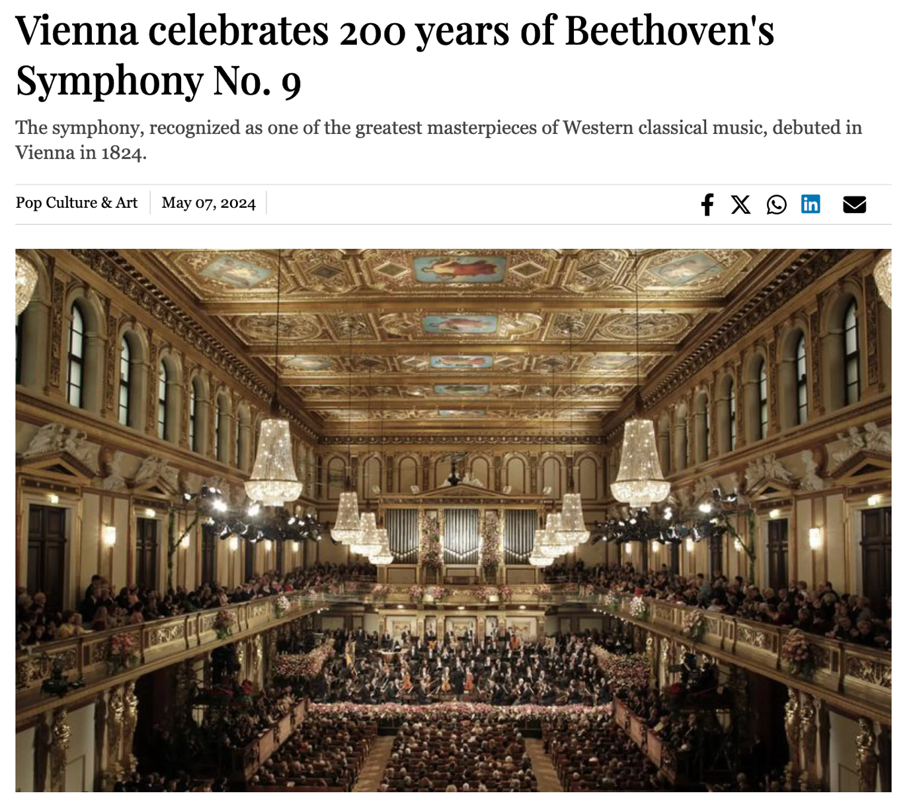

# **April Fools' Day over the decades: Five pranks that made headlines (**[**https://tribune.com.pk/story/2461260/april-fools-day-over-the-decades-five-pranks-that-made-headlines**](https://tribune.com.pk/story/2461260/april-fools-day-over-the-decades-five-pranks-that-made-headlines)**)**

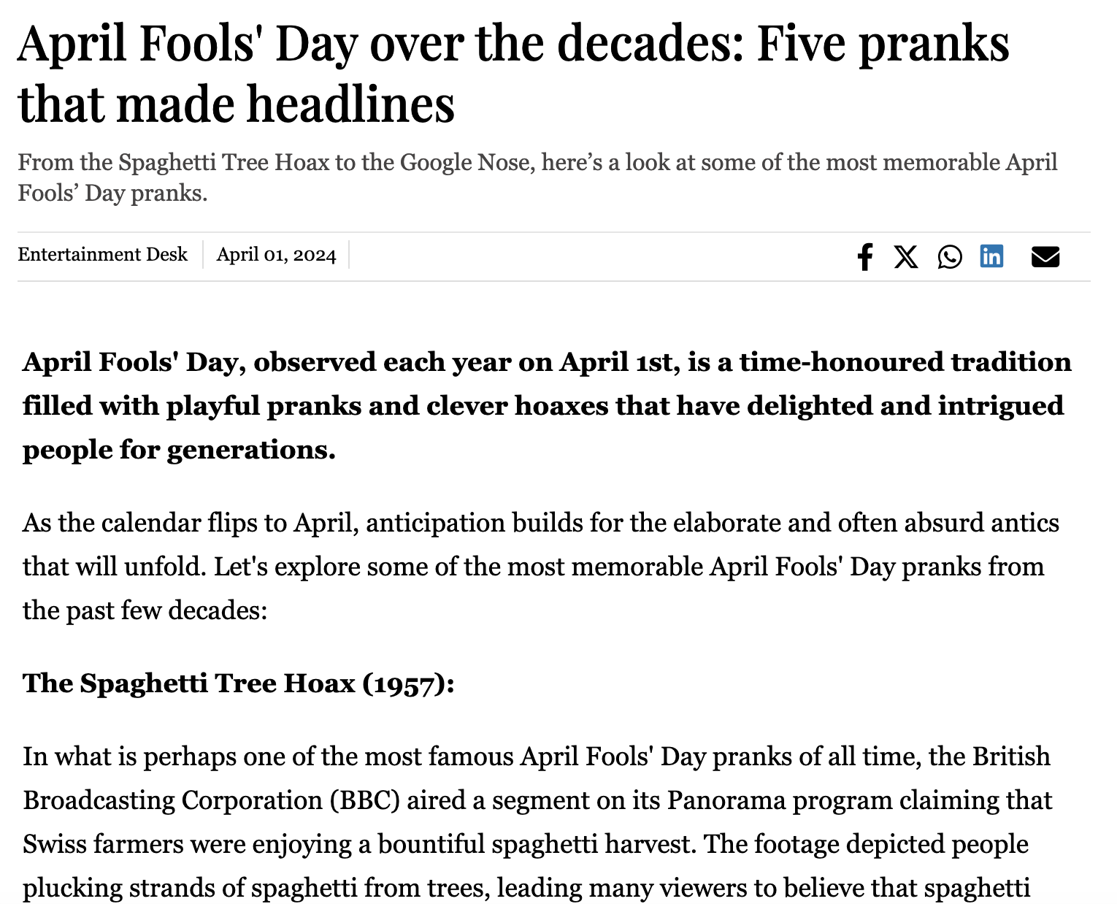

# **NASA astronaut reports strange noise aboard stranded Boeing Starliner (**[**https://tribune.com.pk/story/2493014/nasa-astronaut-reports-strange-noise-aboard-stranded-boeing-starliner**](https://tribune.com.pk/story/2493014/nasa-astronaut-reports-strange-noise-aboard-stranded-boeing-starliner)**)**

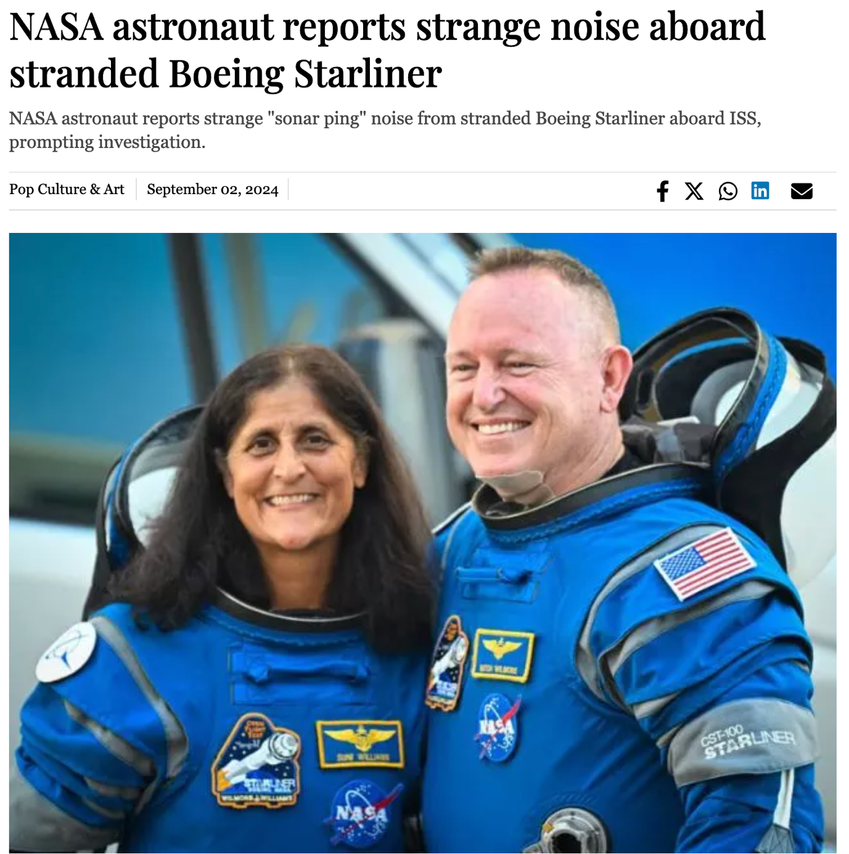

# **King Charles III attends Easter service (**[**https://tribune.com.pk/story/2461252/king-charles-iii-attends-easter-service**](https://tribune.com.pk/story/2461252/king-charles-iii-attends-easter-service)**)**

**

# **1,600 clocks owned by the royal family manually changed this weekend (**[**https://tribune.com.pk/story/2461230/1600-clocks-owned-by-the-royal-family-manually-changed-this-weekend**](https://tribune.com.pk/story/2461230/1600-clocks-owned-by-the-royal-family-manually-changed-this-weekend)**)**

**

# **Is Brad Pitt blind? (**[**https://tribune.com.pk/story/2461761/is-brad-pitt-blind**](https://tribune.com.pk/story/2461761/is-brad-pitt-blind)**)**

**

# **Fans believe Rapper Al B Sure alluded to Sean ‘Diddy’ Combs’ involvement in his 2022 coma (**[**https://tribune.com.pk/story/2461270/fans-believe-rapper-al-b-sure-alluded-to-sean-diddy-combs-involvement-in-his-2022-coma**](https://tribune.com.pk/story/2461270/fans-believe-rapper-al-b-sure-alluded-to-sean-diddy-combs-involvement-in-his-2022-coma)**)**

**

1. **Sabrina Carpenter debuts as star of Kim Kardashian’s new SKIMS campaign (**[**https://tribune.com.pk/story/2461367/sabrina-carpenter-debuts-as-star-of-kim-kardashians-new-skims-campaign**](https://tribune.com.pk/story/2461367/sabrina-carpenter-debuts-as-star-of-kim-kardashians-new-skims-campaign)**)**

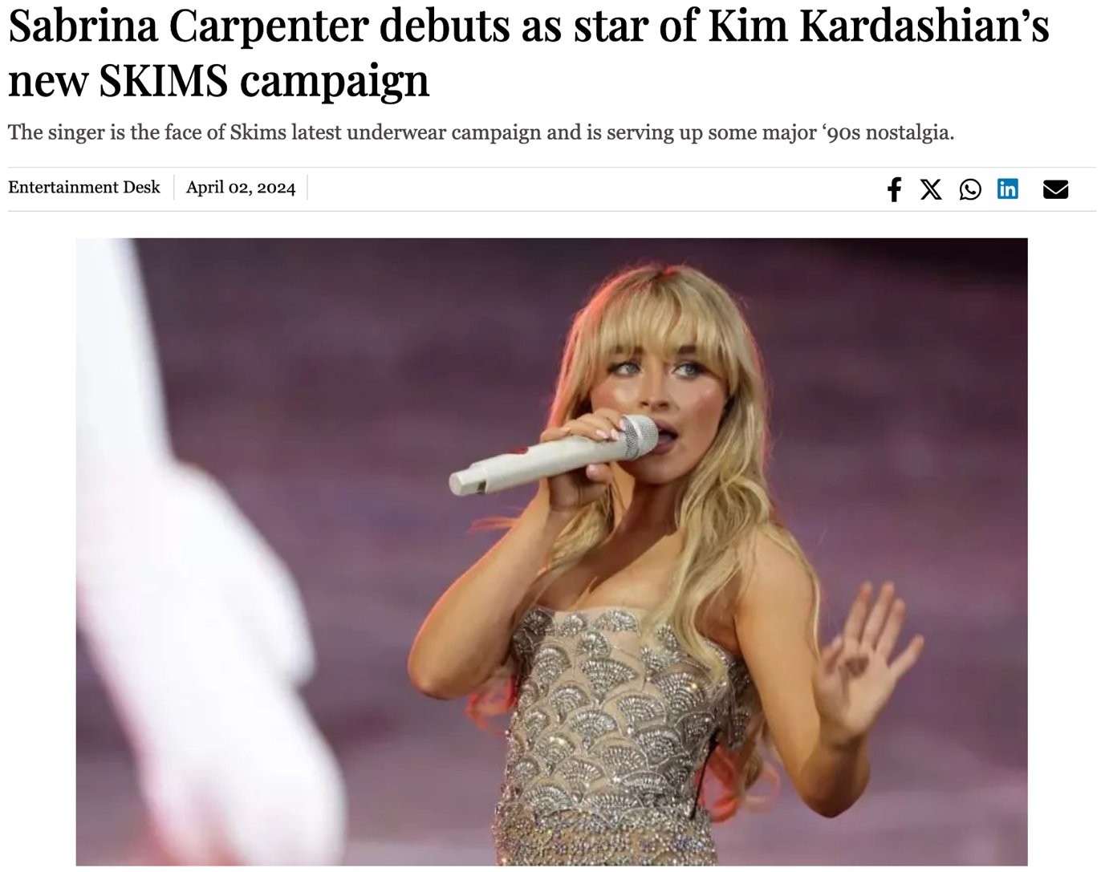

1. **Louis Gossett Jr, first black man to win Best Supporting Actor Oscar, dies at 87 (**[**https://tribune.com.pk/story/2461040/louis-gossett-jr-first-black-man-to-win-best-supporting-actor-oscar-dies-at-87**](https://tribune.com.pk/story/2461040/louis-gossett-jr-first-black-man-to-win-best-supporting-actor-oscar-dies-at-87)**)**

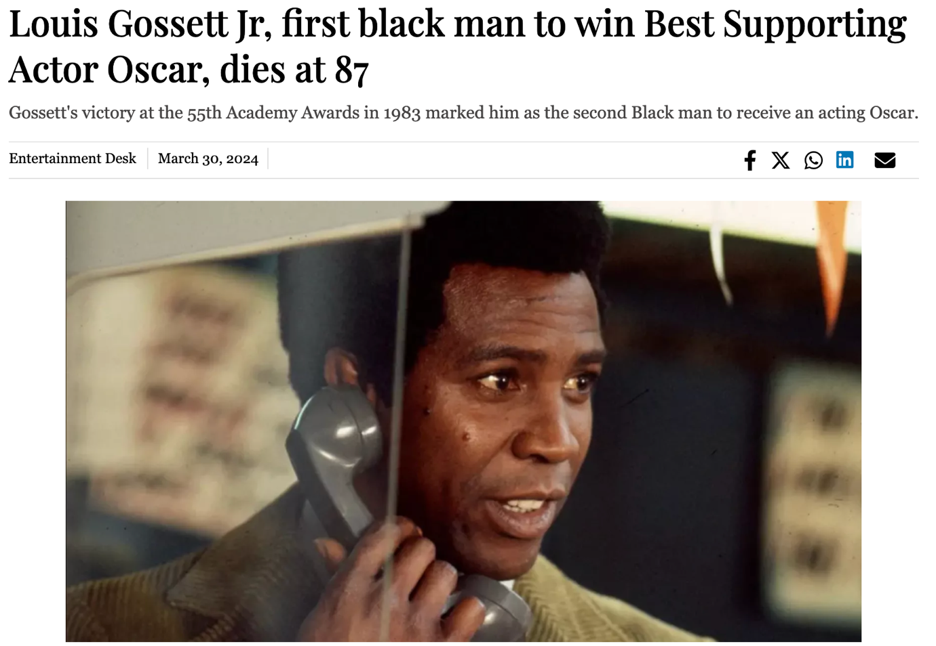

1. **Beyoncé's 'Cowboy Carter' breaks Spotify streaming record (**[**https://tribune.com.pk/story/2461037/beyonces-cowboy-carter-breaks-spotify-streaming-record**](https://tribune.com.pk/story/2461037/beyonces-cowboy-carter-breaks-spotify-streaming-record)**)**

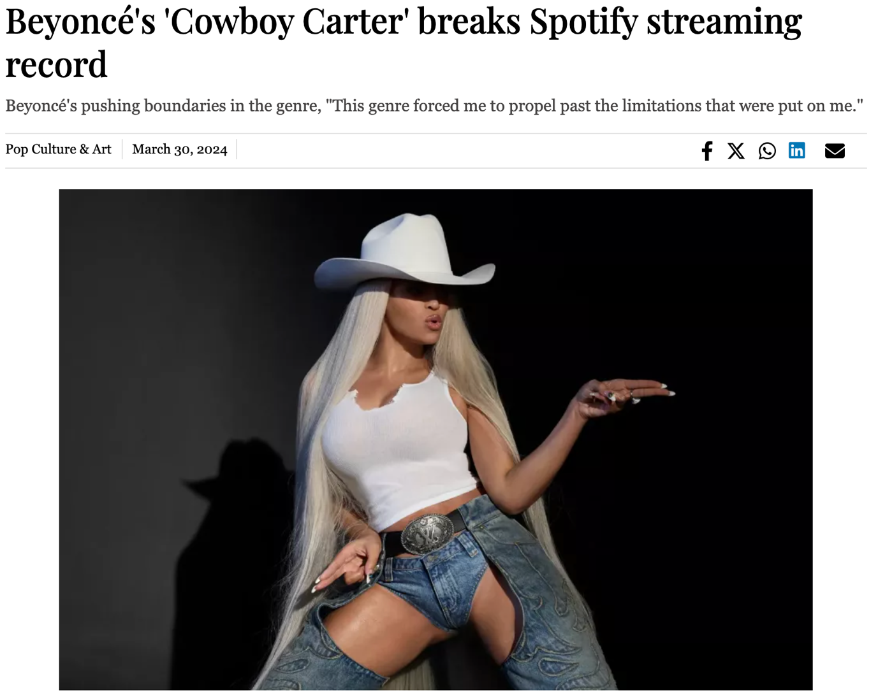

1. **Timothee Chalamet secures Warner Bros deal after success of ‘Dune 2’ and ‘Wonka’ (**[**https://tribune.com.pk/story/2460702/timothee-chalamet-secures-warner-bros-deal-after-success-of-dune-2-and-wonka**](https://tribune.com.pk/story/2460702/timothee-chalamet-secures-warner-bros-deal-after-success-of-dune-2-and-wonka)**)**

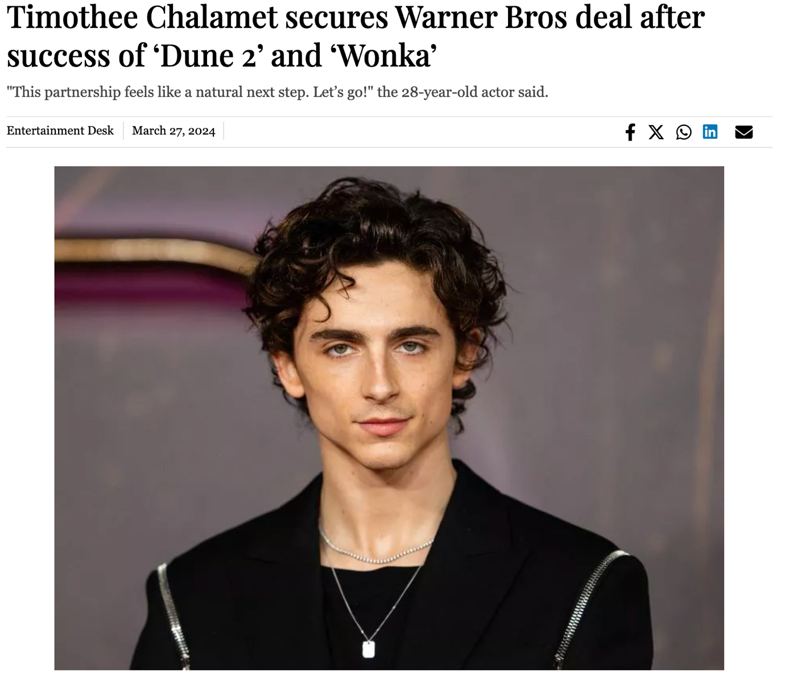

1. **Conjoined twin Abby Hensel reveals 2021 marriage to US army veteran Josh Bowling (**[**https://tribune.com.pk/story/2460943/conjoined-twin-abby-hensel-reveals-2021-marriage-to-us-army-veteran-josh-bowling**](https://tribune.com.pk/story/2460943/conjoined-twin-abby-hensel-reveals-2021-marriage-to-us-army-veteran-josh-bowling)**)**

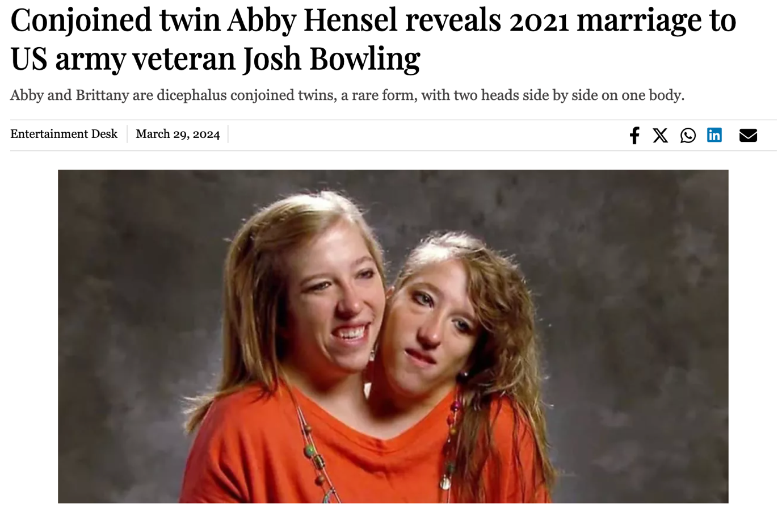

# **Marvel’s former star Jonathan Majors sentenced to probation in assault case (**[**https://tribune.com.pk/story/2462177/marvels-former-star-jonathan-majors-sentenced-to-probation-in-assault-case**](https://tribune.com.pk/story/2462177/marvels-former-star-jonathan-majors-sentenced-to-probation-in-assault-case)**)**

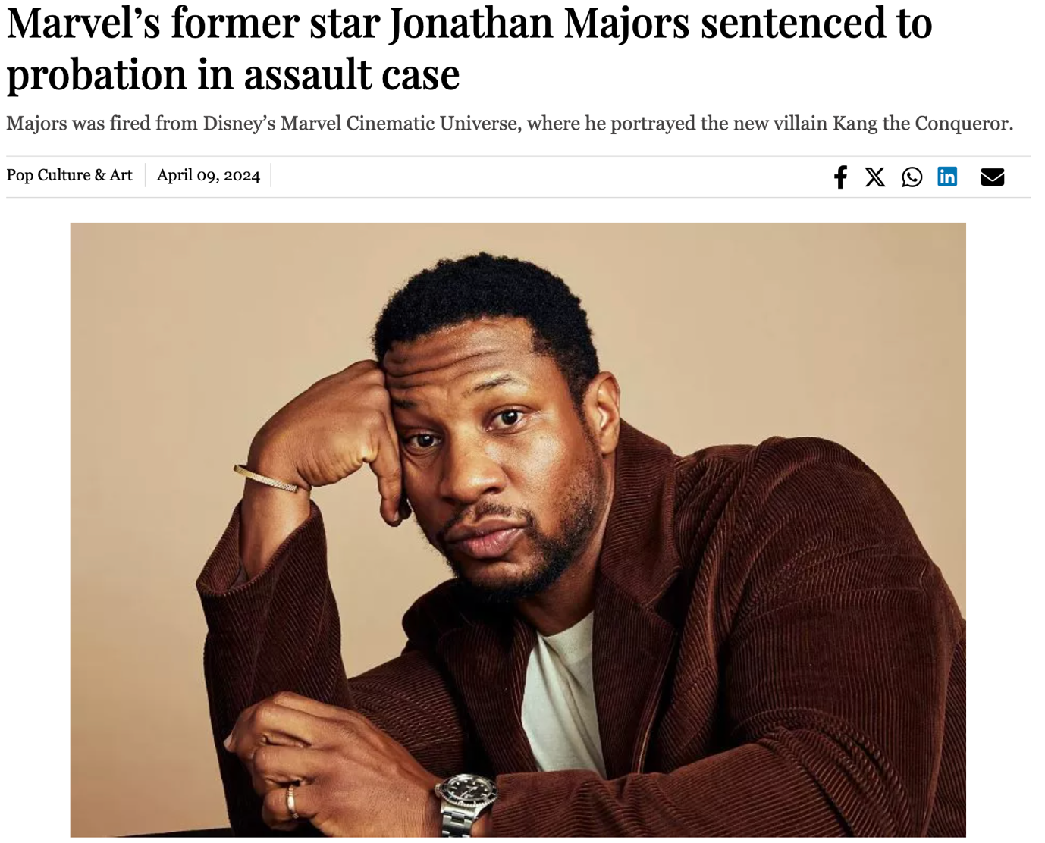

1. Billie Eilish announces release of third album: "Hit Me Hard and Soft" (<https://tribune.com.pk/story/2462168/bille-eilish-announces-release-of-third-album-hit-me-hard-and-soft>)

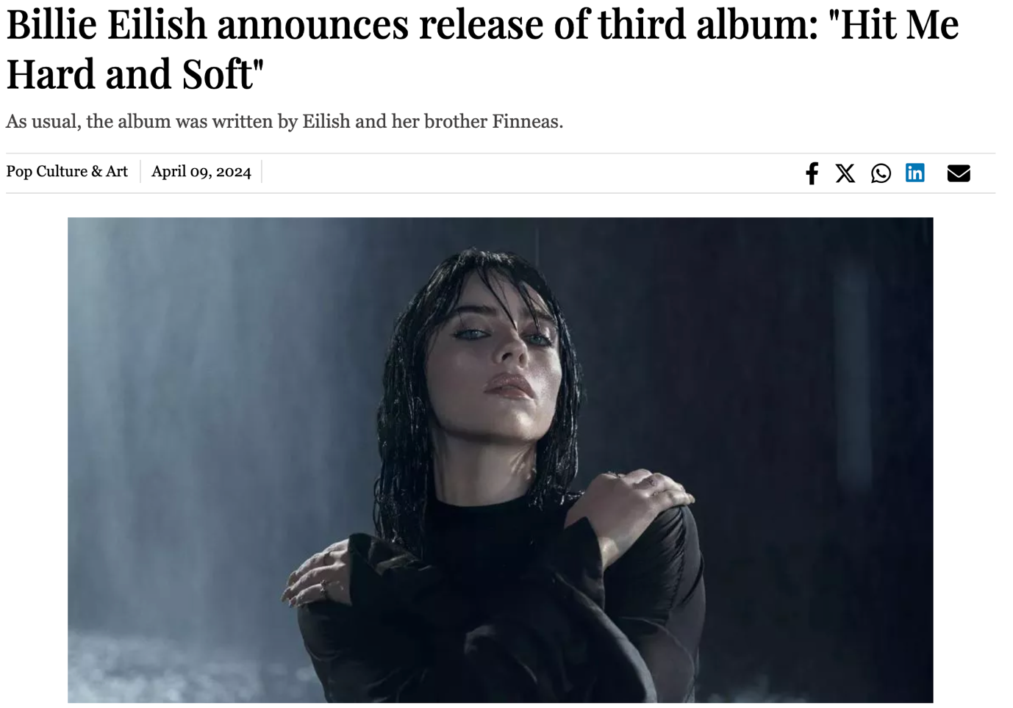

1. Country star Morgan Wallen arrested for three counts of reckless endangerment (<https://tribune.com.pk/story/2462057/country-star-morgan-wallen-arrested-on-felony-charges-in-nashville>)

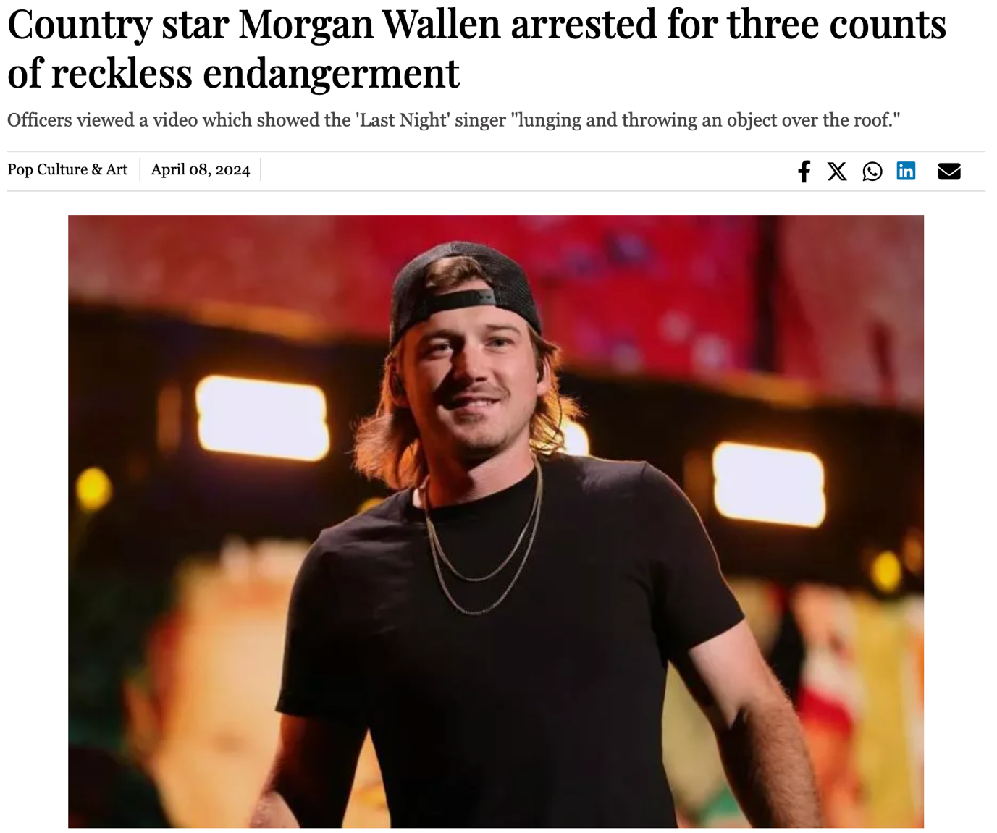

1. Joaquin Phoenix’s Joker, Lady Gaga’s Harley Quinn join forces in new trailer for ‘Joker 2’ (<https://tribune.com.pk/story/2462309/joaquin-phoenixs-joker-lady-gagas-harley-quinn-join-forces-in-new-trailer-for-joker-2>)

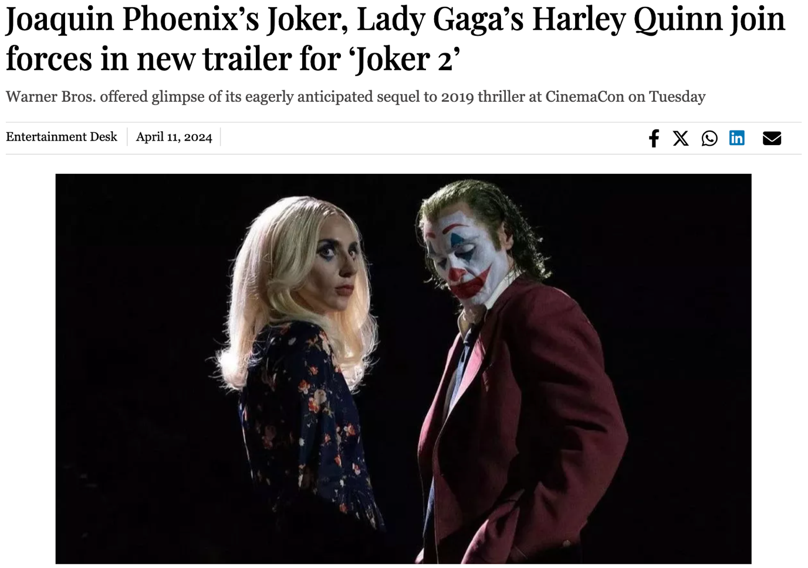

1. Taylor Swift's music returns to TikTok despite ongoing licensing dispute (<https://tribune.com.pk/story/2462356/taylor-swifts-music-returns-to-tiktok-despite-ongoing-licensing-dispute>)

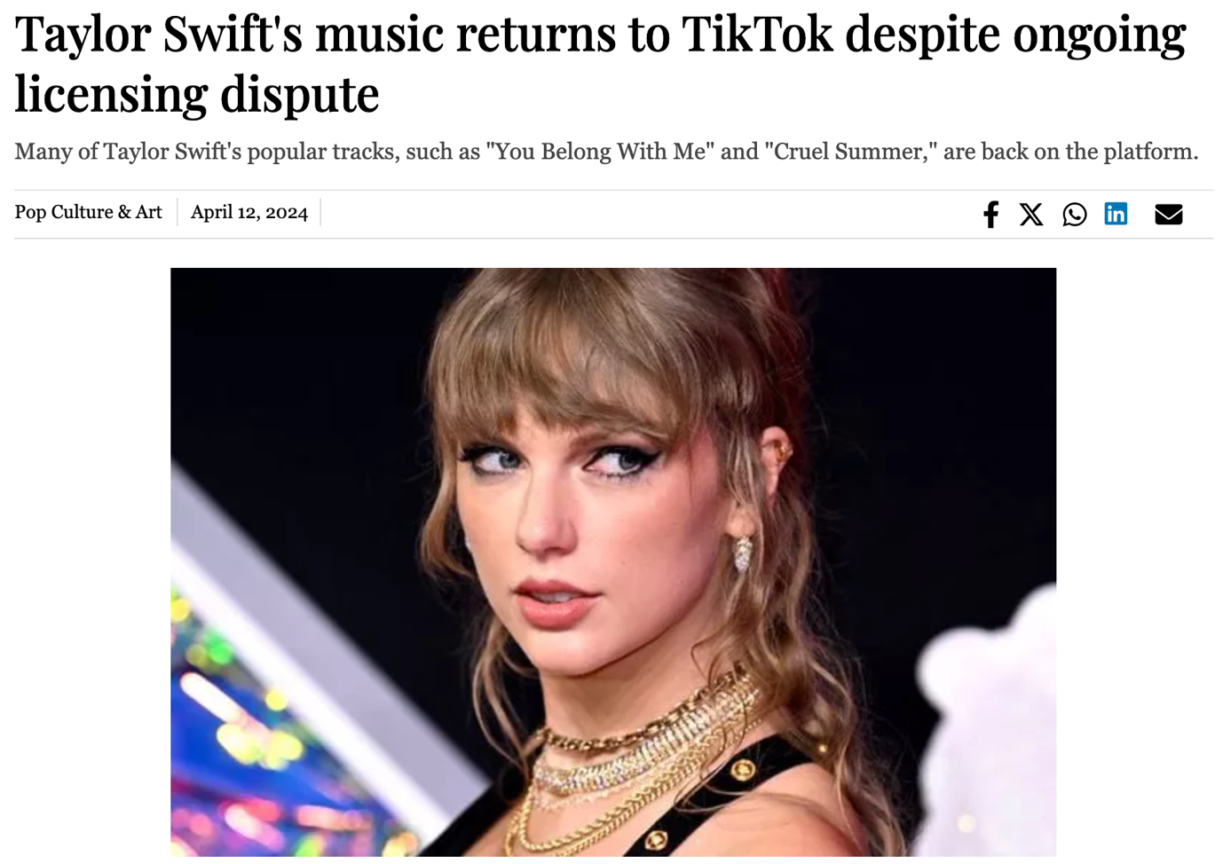

1. Coachella 2024: Festival kicks off in the desert (<https://tribune.com.pk/story/2462341/coachella-2024-festival-kicks-off-in-the-desert>)

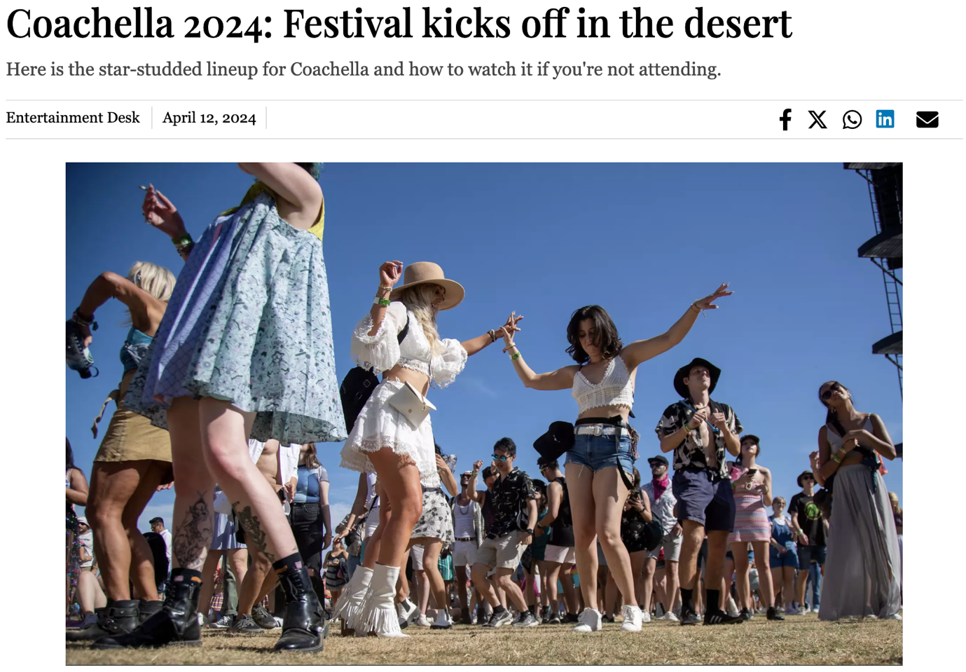

1. Jameela Jamil say “20 years of dieting has hurt my bone density” (<https://tribune.com.pk/story/2463044/jameela-jamil-say-20-years-of-dieting-has-hurt-my-bone-density>)

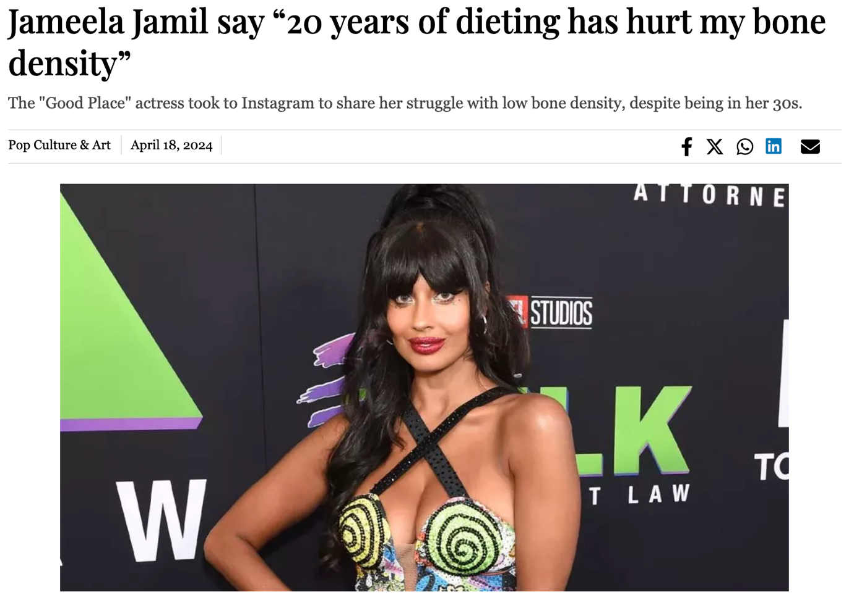

1. Apink's Bomi and Black Eyed Pilseung's Rado: A 7-Year Love Story (<https://tribune.com.pk/story/2463621/apinks-bomi-and-black-eyed-pilseungs-rado-a-7-year-love-story>)

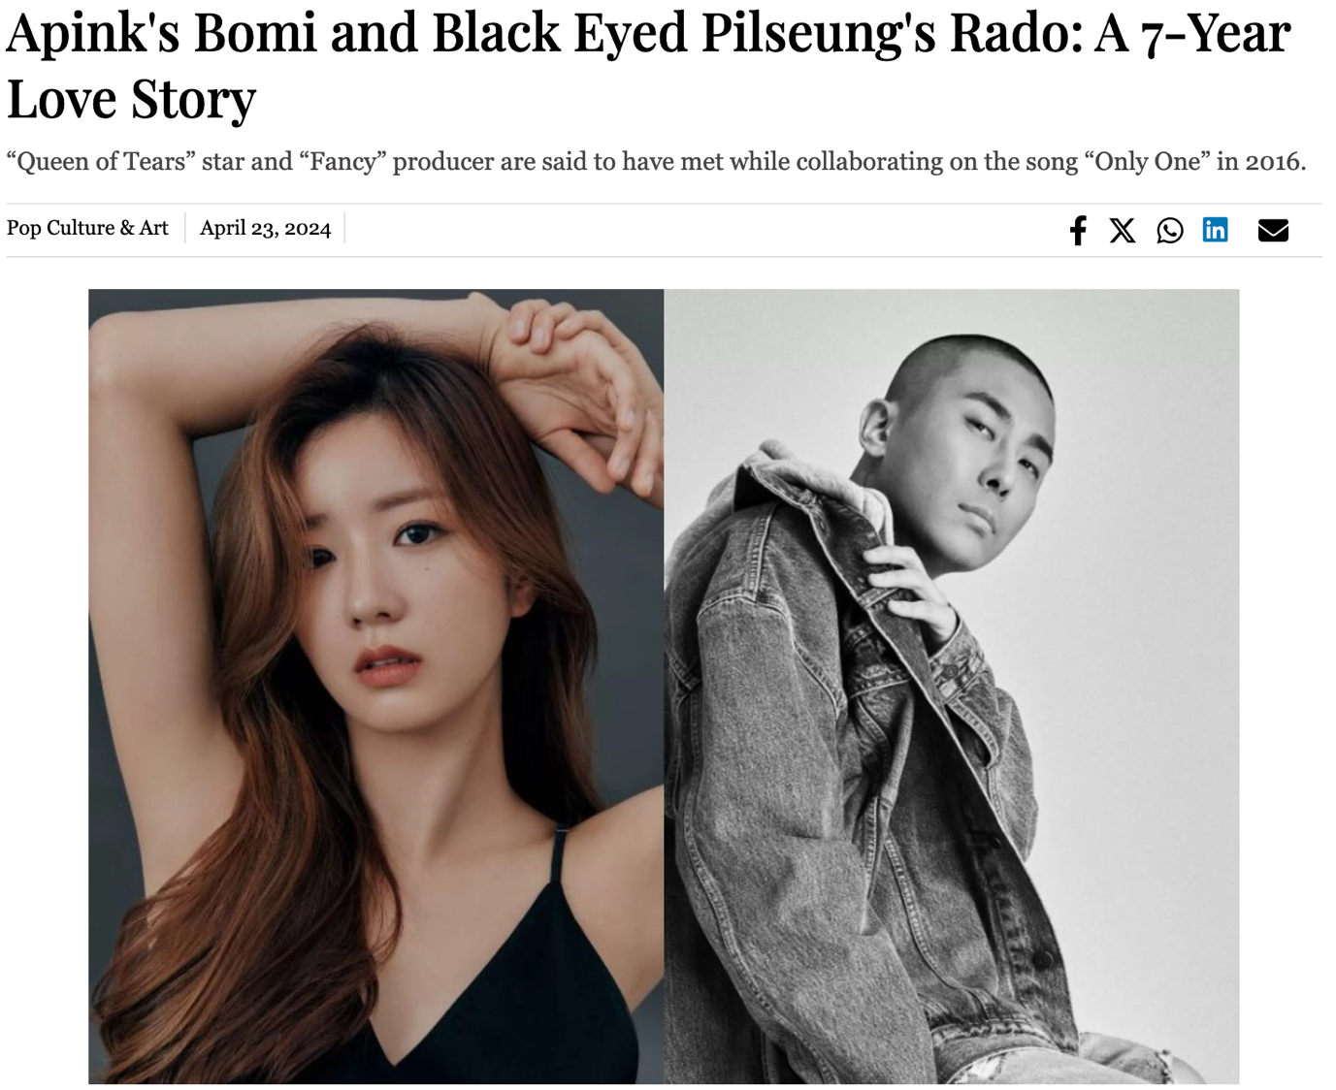

# TikToker and famous gymnast Olivia Dunne wins NCAA Championship with LSU team (<https://tribune.com.pk/story/2463409/tiktoker-and-famous-gymnast-olivia-dunne-wins-ncaa-championship-with-lsu-team>)

1. Beyoncé Addresses Wig Rumors and Introduces Cécred Haircare Line (<https://tribune.com.pk/story/2463640/beyonce-addresses-wig-rumors-and-introduces-cecred-haircare-line>)

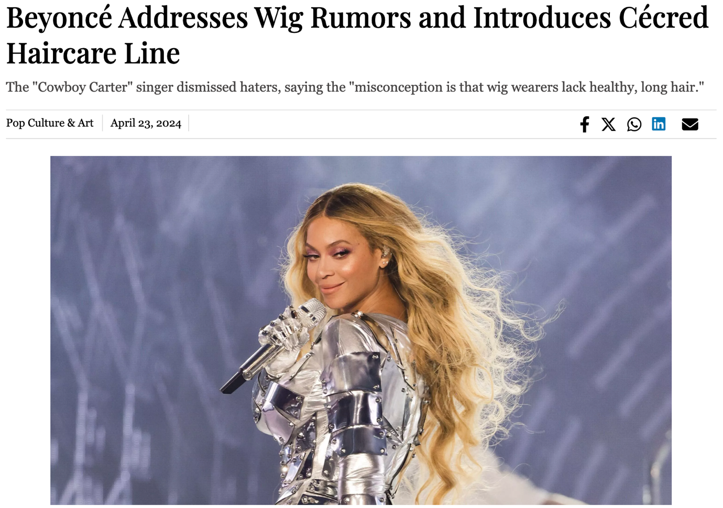

1. Celine Dion opens up about stiff person syndrome (<https://tribune.com.pk/story/2463633/celine-dion-opens-up-about-stiff-person-syndrome>)

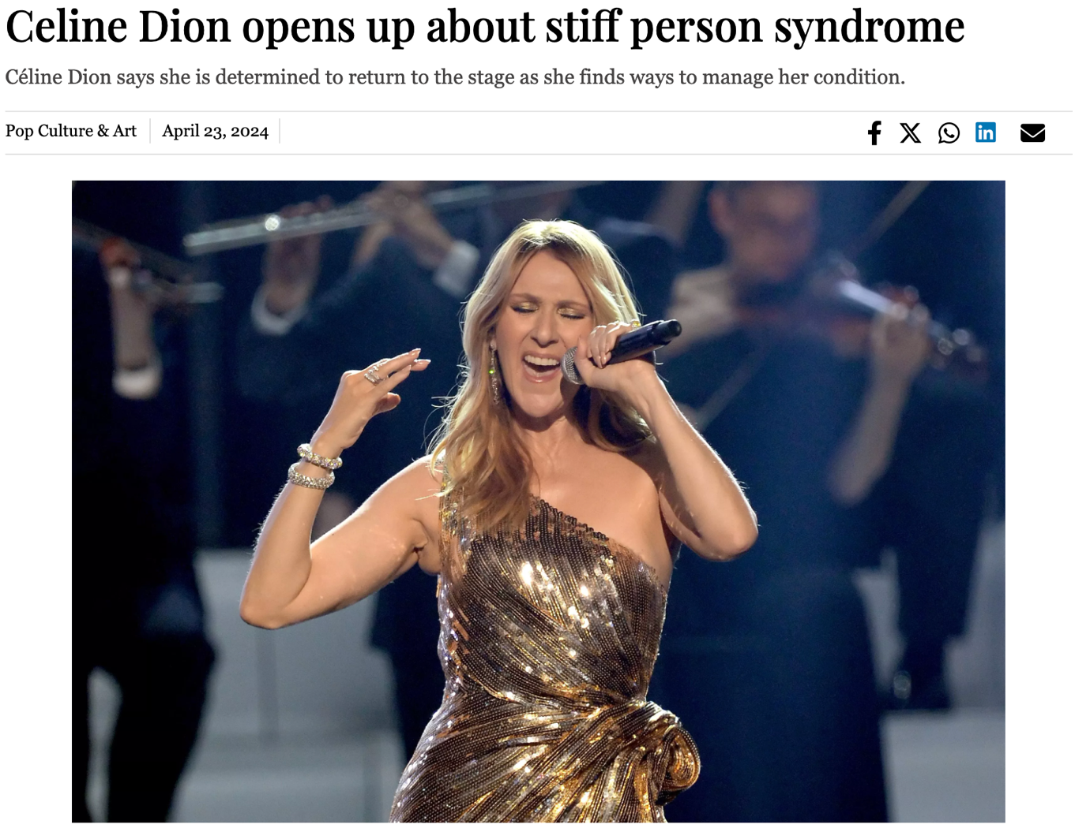

1. The Simpsons: all the characters written off the show (<https://tribune.com.pk/story/2464081/the-simpsons-all-the-characters-written-off-the-show>)

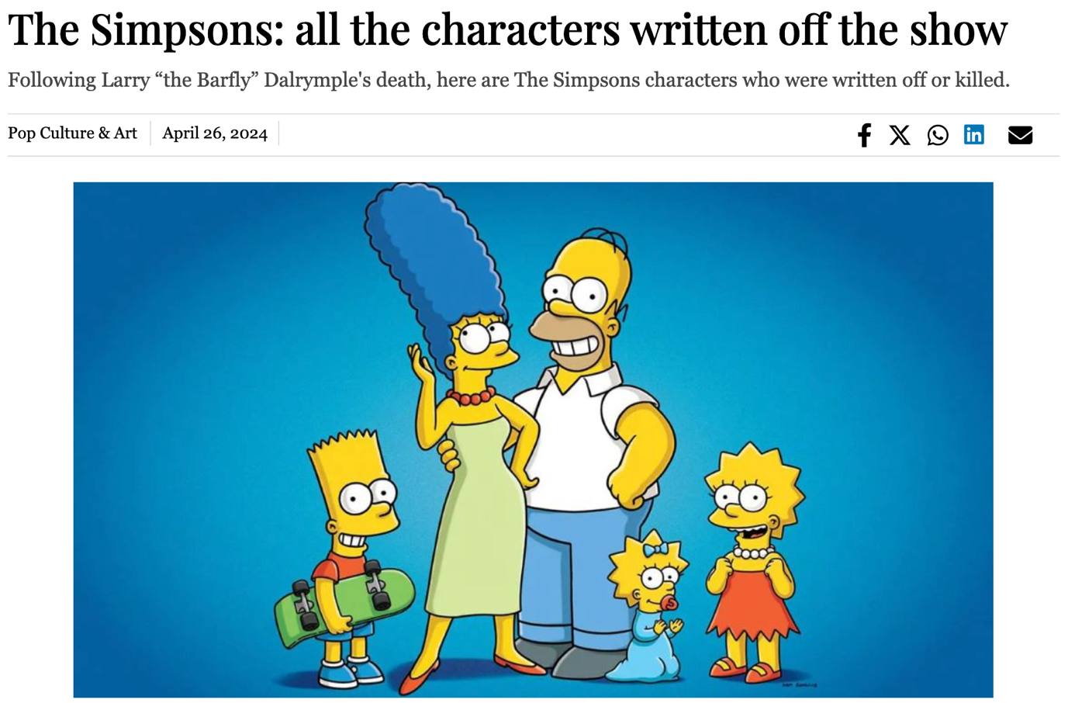

1. Kanye West sued for racism by Donda Academy staff (<https://tribune.com.pk/story/2464040/kanye-west-sued-for-racism-by-donda-academy-staff>)

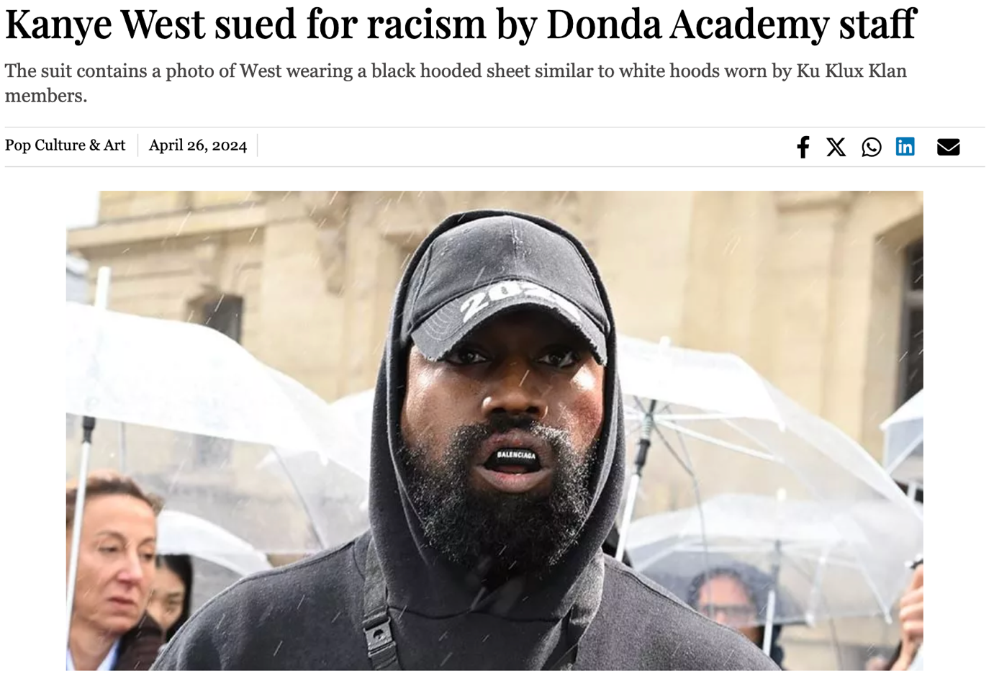

1. Andrew Tate and Tristan set to go to trial in Romania for human trafficking charges (<https://tribune.com.pk/story/2464174/andrew-tate-and-tristan-set-to-go-to-trial-in-romania-for-human-trafficking-charges>)

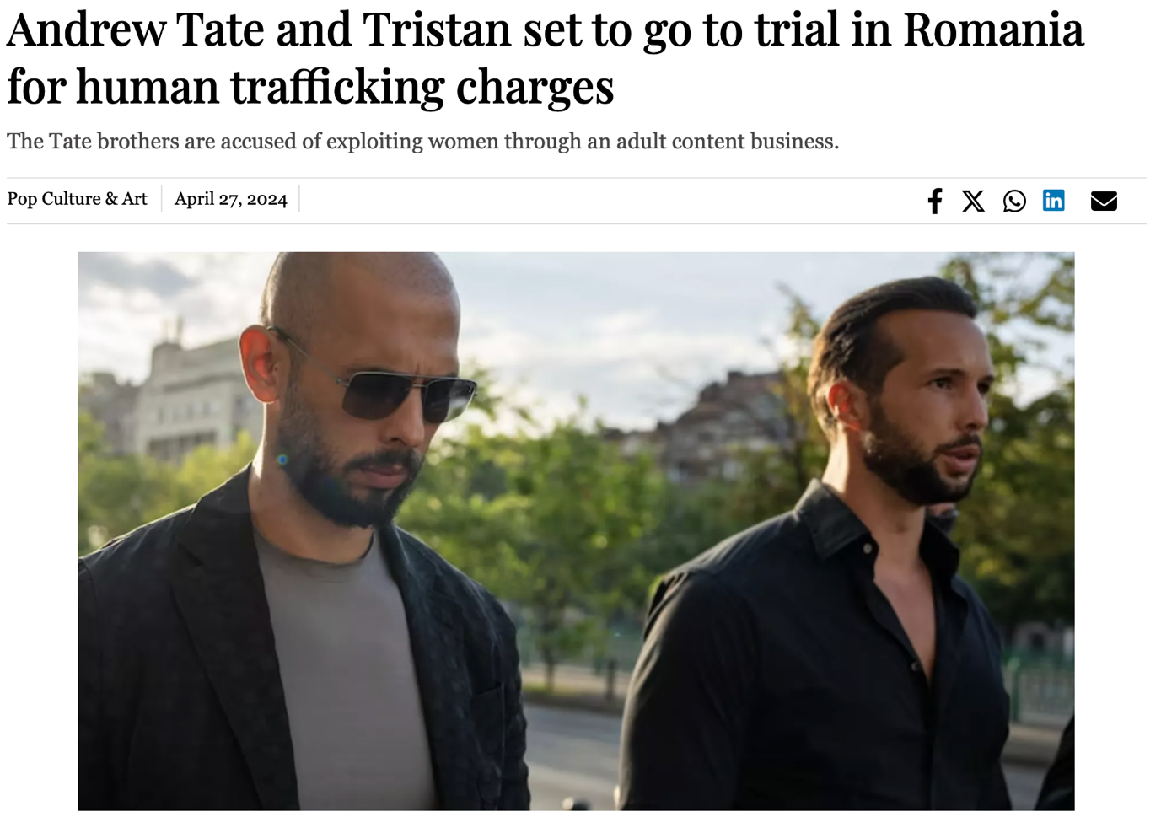

1. Harvey Weinstein’s 2020 rape conviction overturned (<https://tribune.com.pk/story/2464028/harvey-weinsteins-2020-rape-conviction-overturned>)

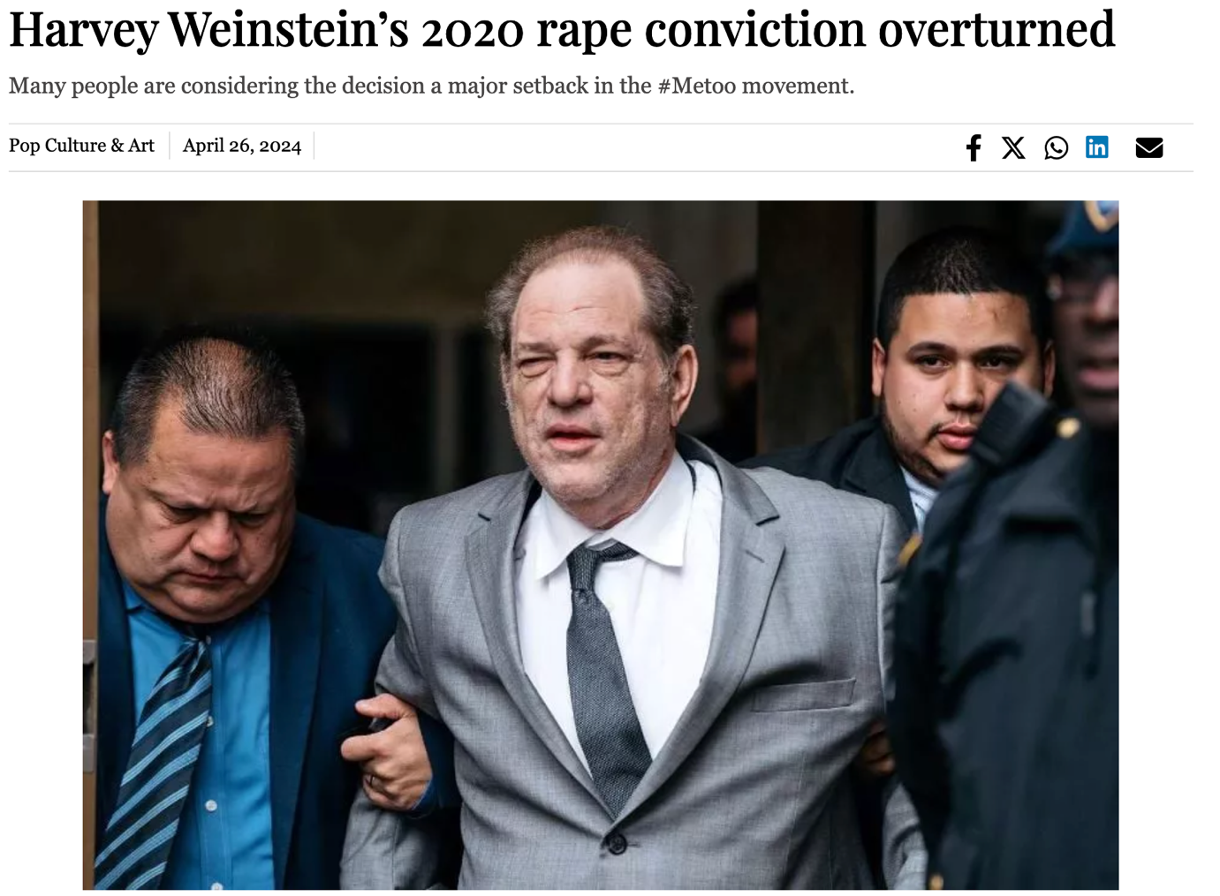

1. "Kalki 2898 AD" movie poster unveiled: Prabhas, Amitabh Bachchan and Deepika Padukone to star (<https://tribune.com.pk/story/2464230/kalki-2898-ad-movie-poster-unveiled-prabhas-amitabh-bachchan-and-deepika-padukone-to-star>)

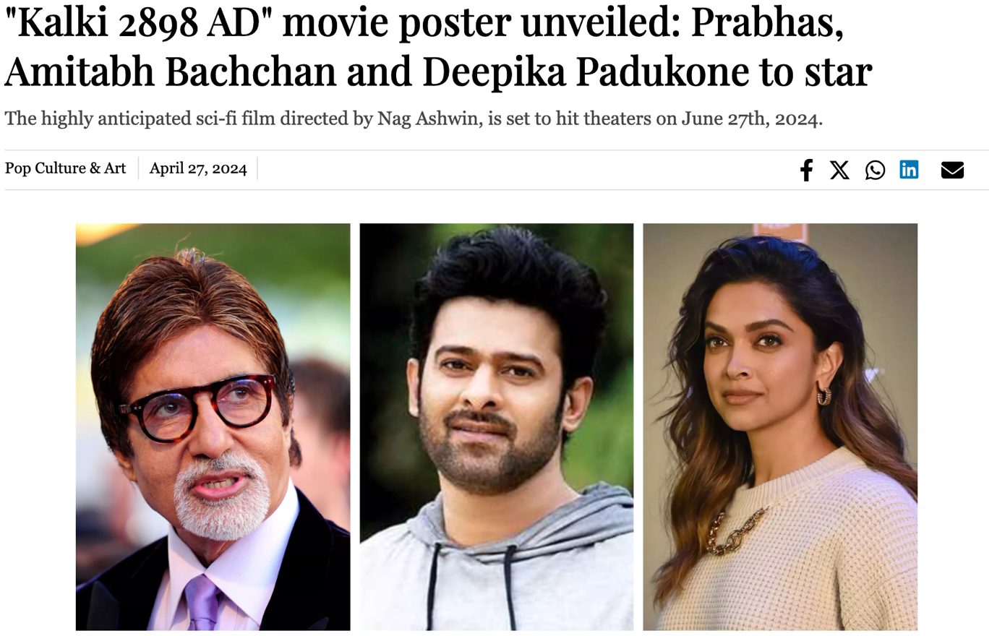

1. O.J. Simpson’s cause of death revealed two weeks after passing (<https://tribune.com.pk/story/2464216/oj-simpsons-cause-of-death-revealed-two-weeks-after-passing>)

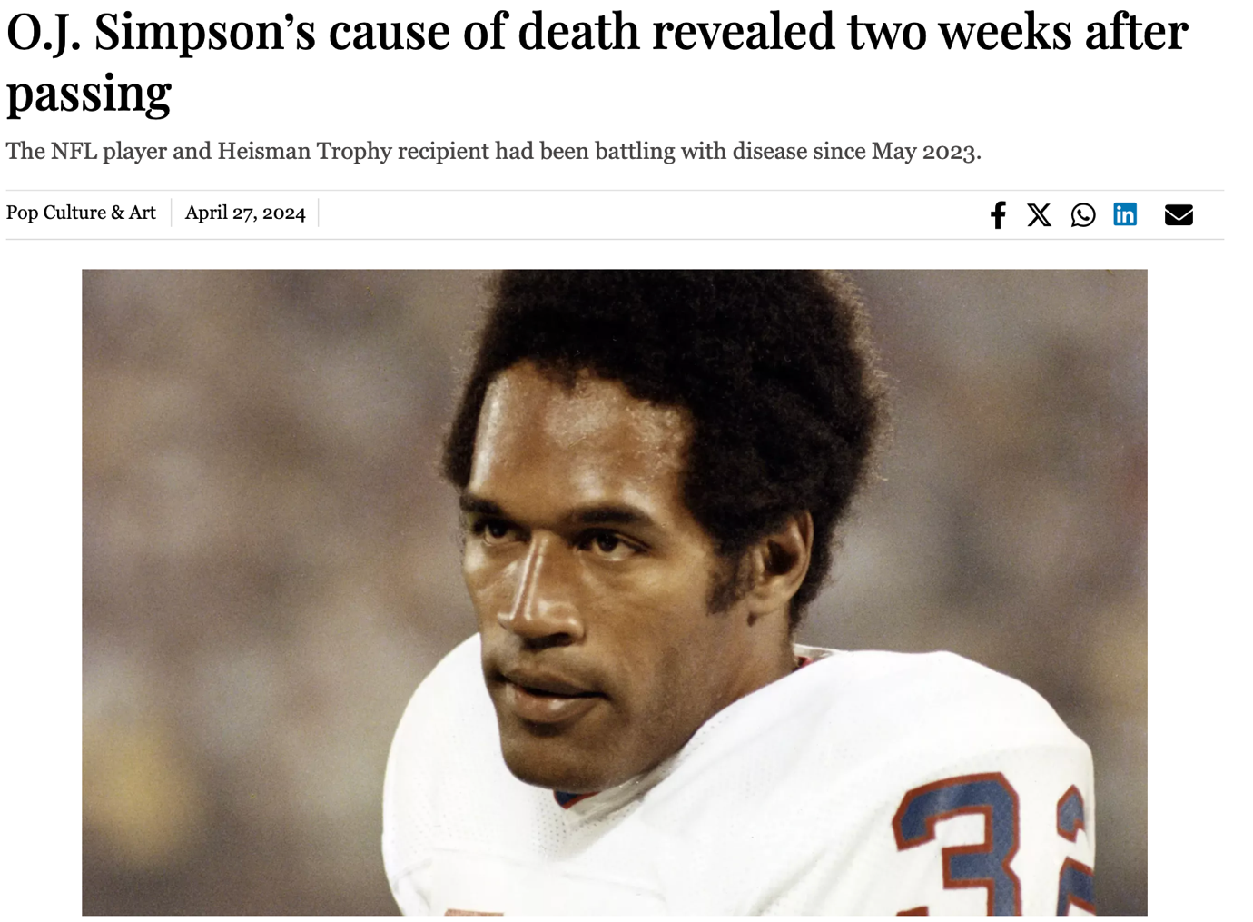

1. Benny Blanco gushes over Selena Gomez: “I’m in love!” (<https://tribune.com.pk/story/2464196/benny-blanco-gushes-over-selena-gomez-im-in-love>)

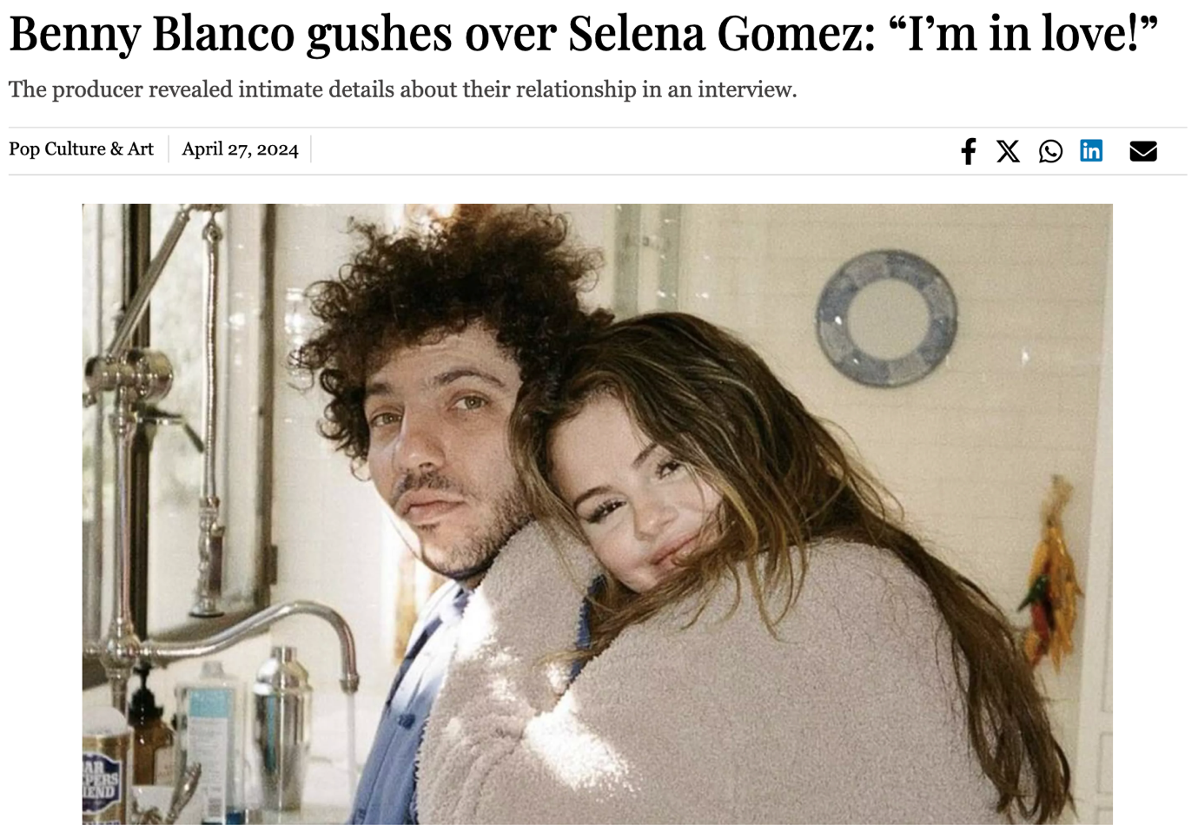

1. Met Gala 2024: theme, guests, and how to watch (<https://tribune.com.pk/story/2464570/met-gala-2024-theme-guests-and-how-to-watch>)

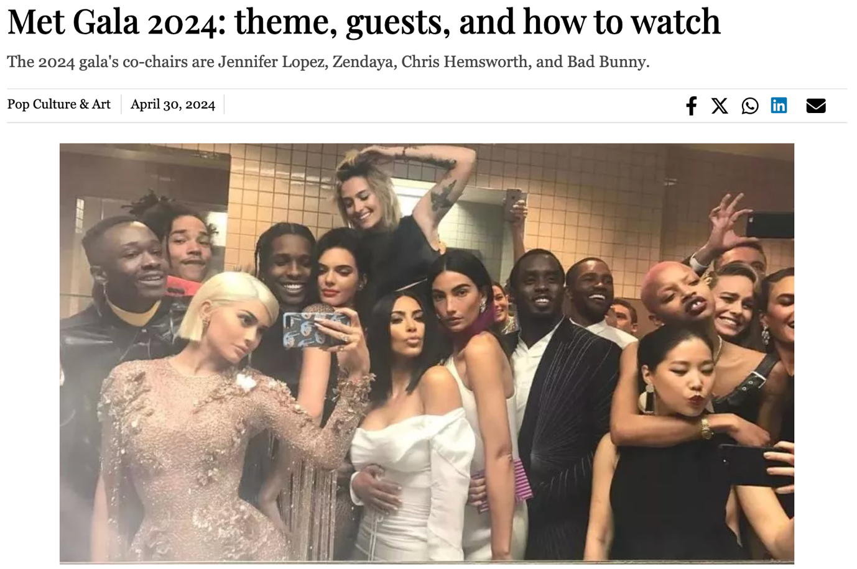

1. Slack and Flickr co-founders speak out after kidnapped daughter found in the back of van (<https://tribune.com.pk/story/2464622/slack-and-flickr-co-founders-speak-out-after-kidnapped-daughter-found-in-the-back-of-van>)

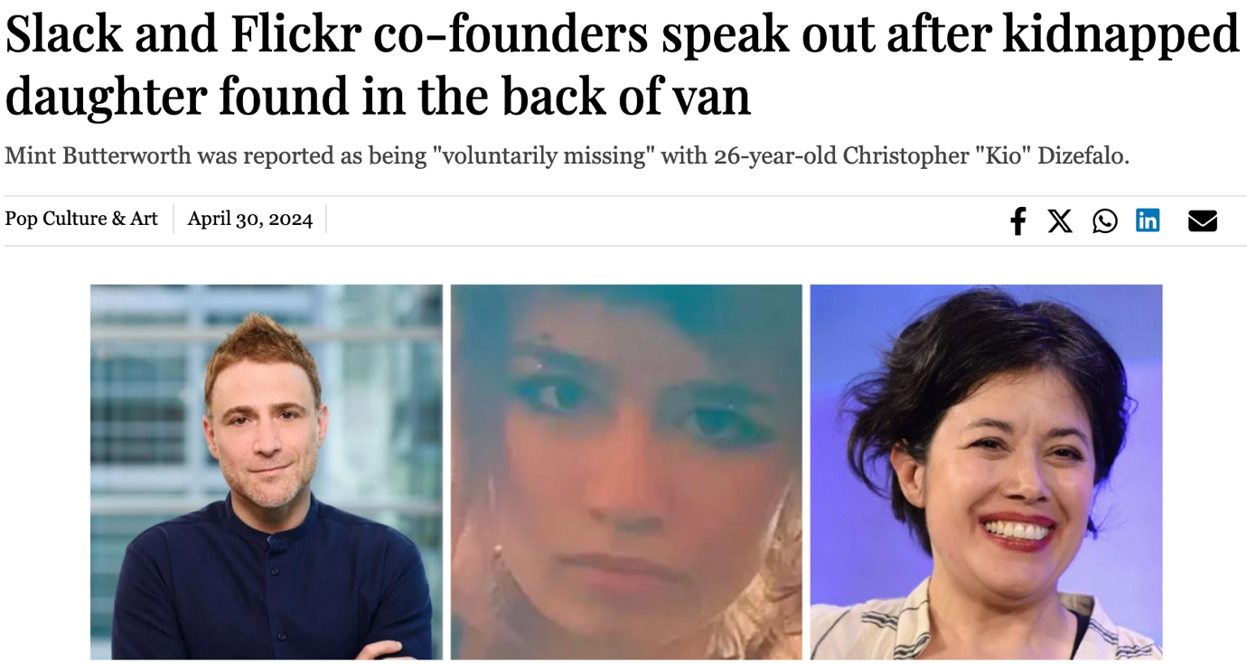

1. ‘I AM SILENCED’: Is Miss USA’s resignation post a cry for help? (<https://tribune.com.pk/story/2465533/i-am-silenced-is-miss-usas-resignation-post-a-cry-for-help>)

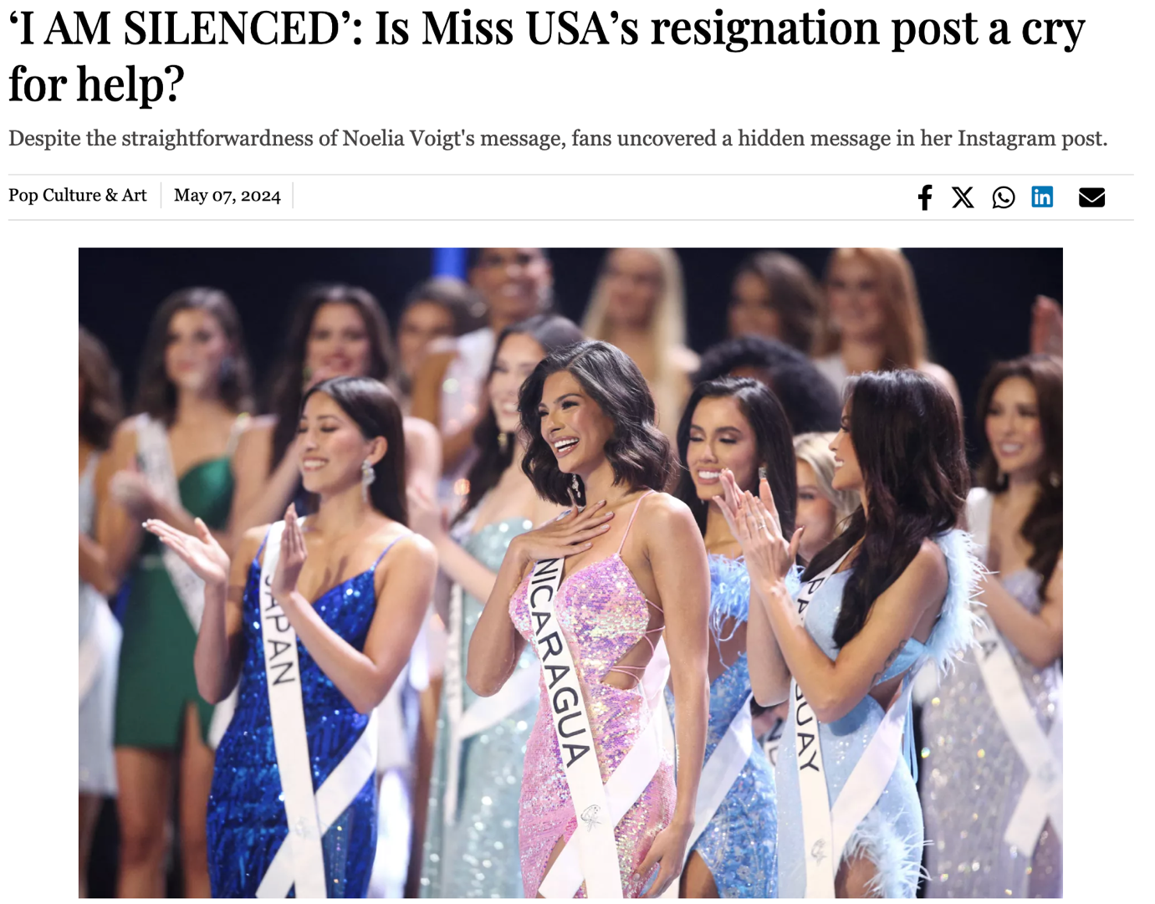

1. Stevie Wonder arrives in Ghana in time to celebrate his 74th birthday (<https://tribune.com.pk/story/2466382/stevie-wonder-arrives-in-ghana-in-time-to-celebrate-his-74th-birthday>)

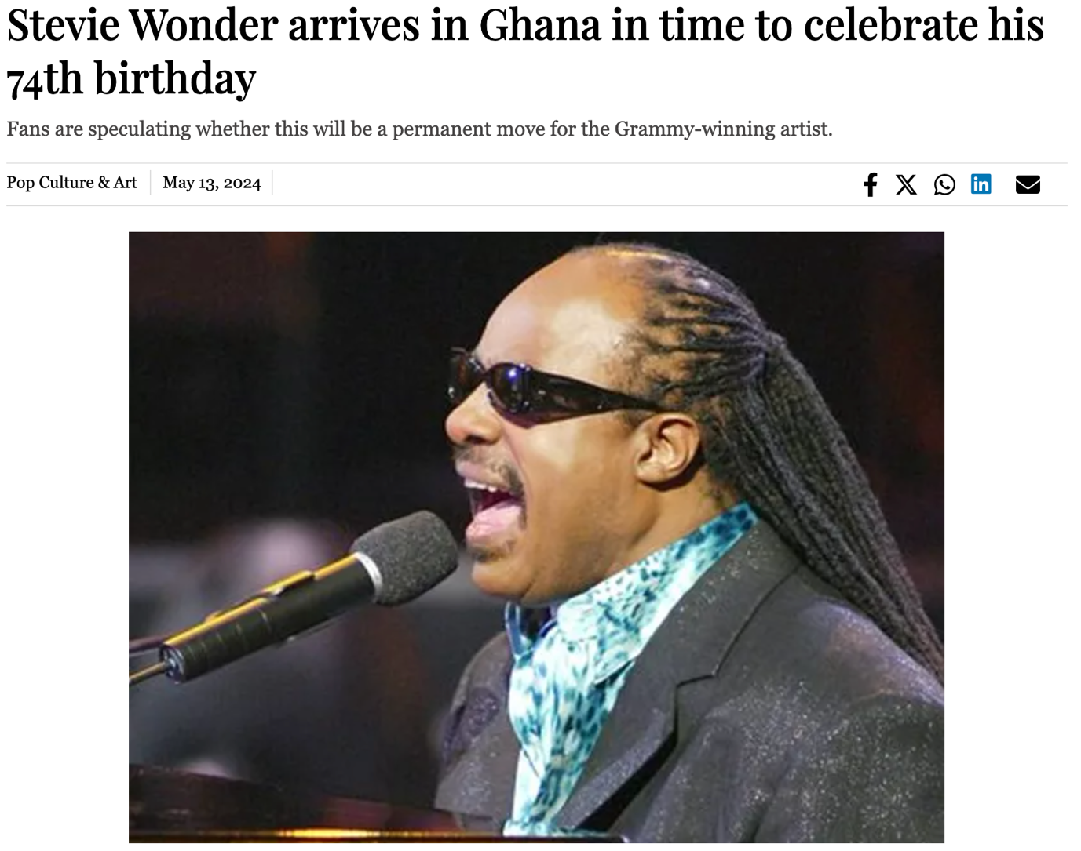

1. TikTok's "Digitine" movement targets celebrities for social media blocking (<https://tribune.com.pk/story/2466358/tiktoks-digitine-movement-targets-celebrities-for-social-media-blocking>)

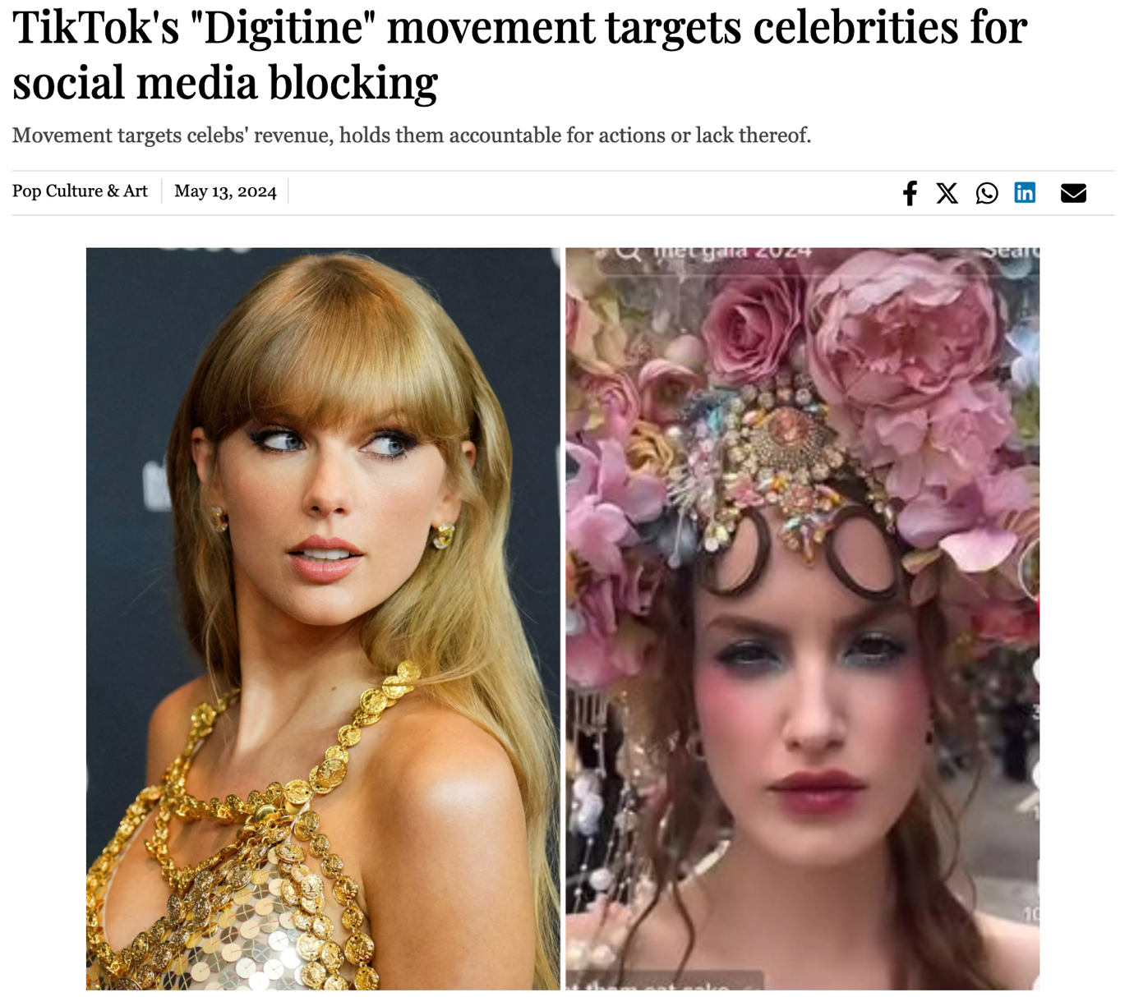

1. Emma D'Arcy and Olivia Cooke talk House of the Dragon and Negroni Spagliato Meme (<https://tribune.com.pk/story/2466644/emma-darcy-and-olivia-cooke-talk-house-of-the-dragon-and-negroni-spagliato-meme>)

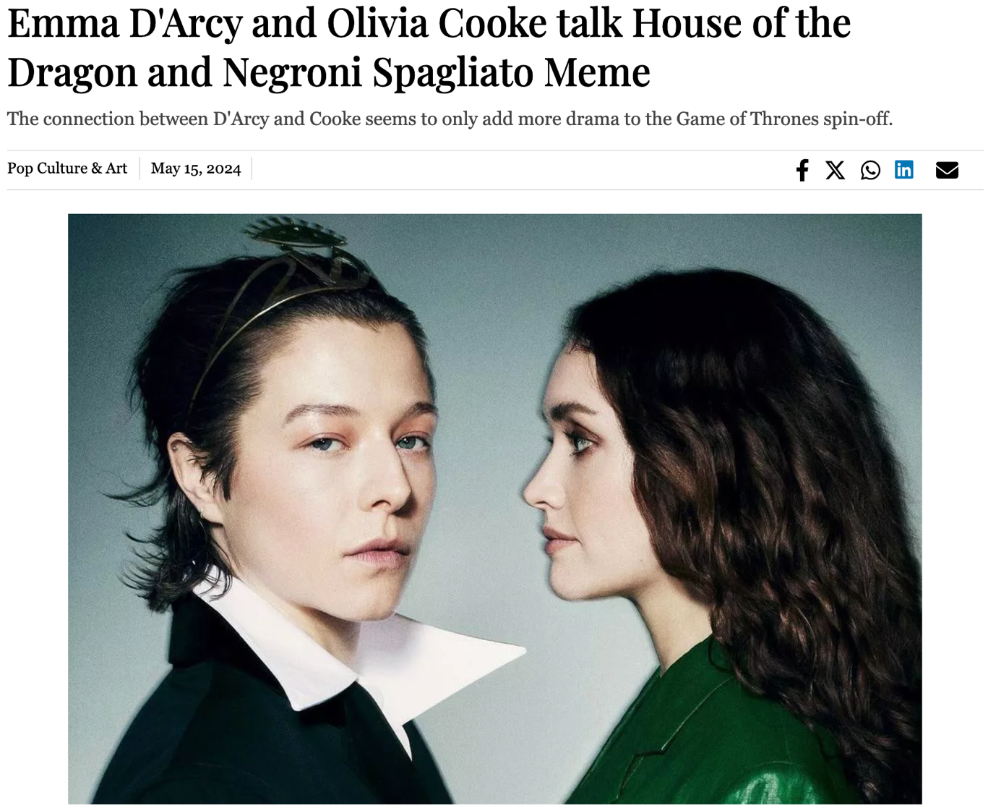

1. YouTuber Nancy Tyagi debuts at Cannes in 20kg self-stitched gown (<https://tribune.com.pk/story/2467181/youtuber-nancy-tyagi-debuts-at-cannes-in-20kg-self-stitched-gown>)

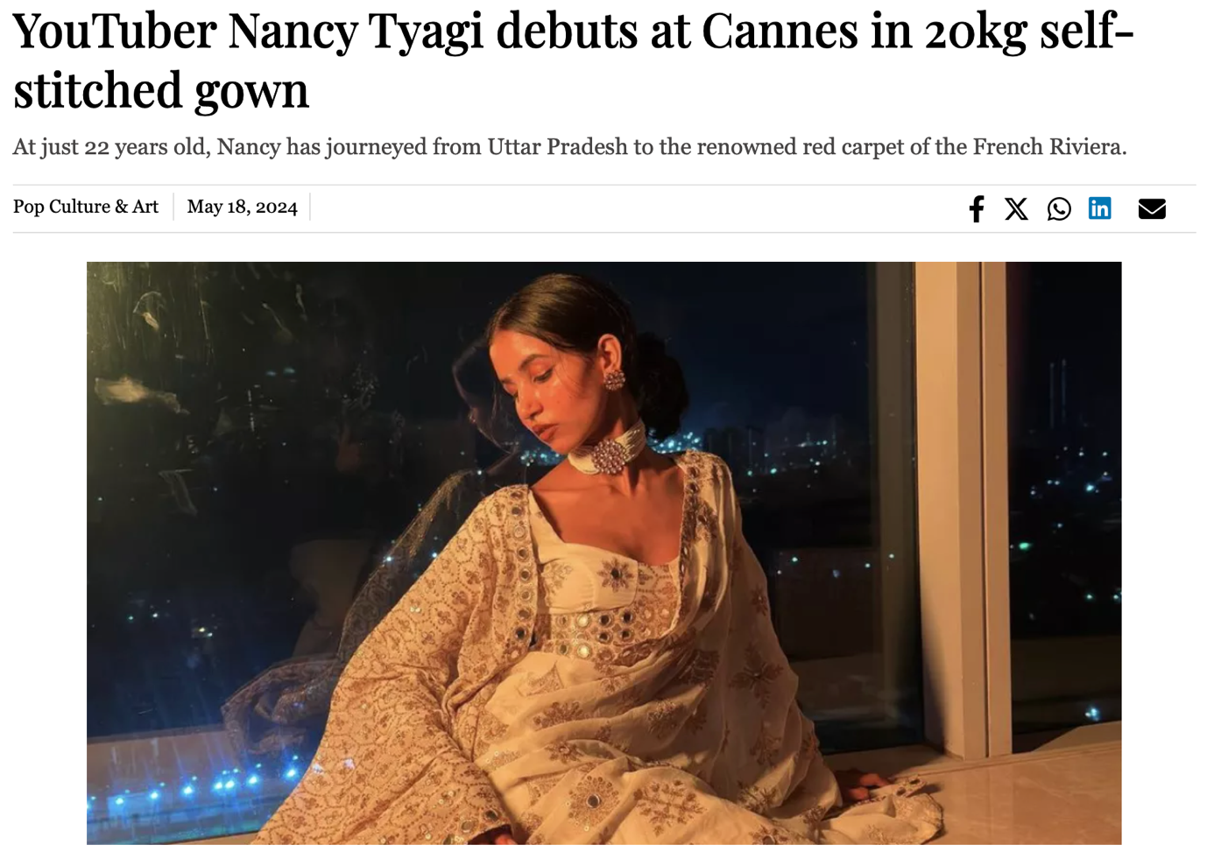

1. Star Wars: The Acolyte: premiere, release date, storyline, cast and trailer (<https://tribune.com.pk/story/2468065/star-wars-the-acolyte-premiere-release-date-storyline-cast-and-trailer>)

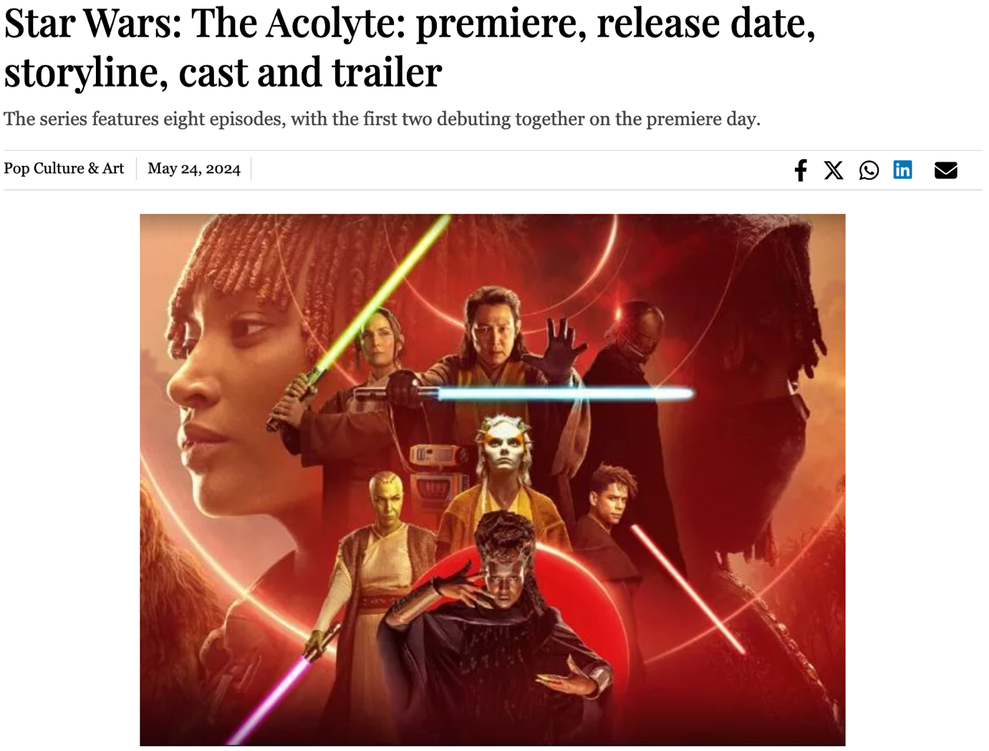

1. Billie Joe Armstrong to Katy Perry: the biggest celebrities who attended Taylor Swift’s Eras Tour (<https://tribune.com.pk/story/2469728/billie-joe-armstrong-to-katy-perry-the-biggest-celebrities-who-attended-taylor-swifts-eras-tour>)

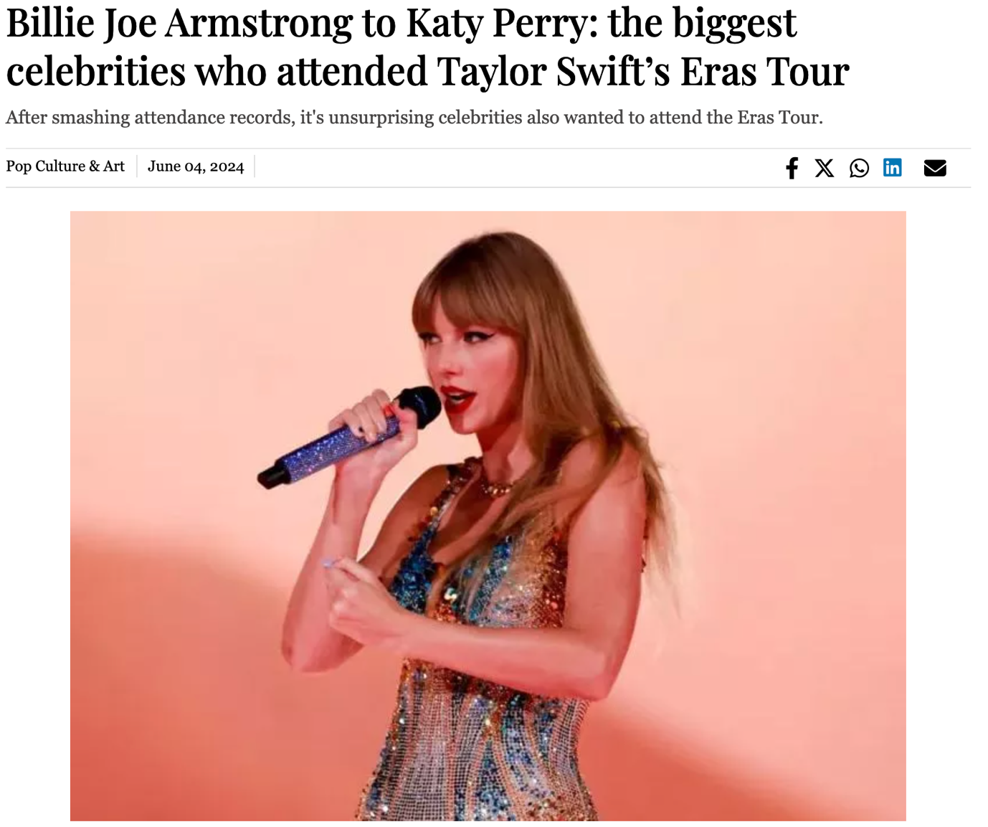

1. Who is Stormy Daniels? The adult film star who took down a former US President (<https://tribune.com.pk/story/2469095/who-is-stormy-daniels-the-adult-film-star-who-took-down-a-former-us-president>)

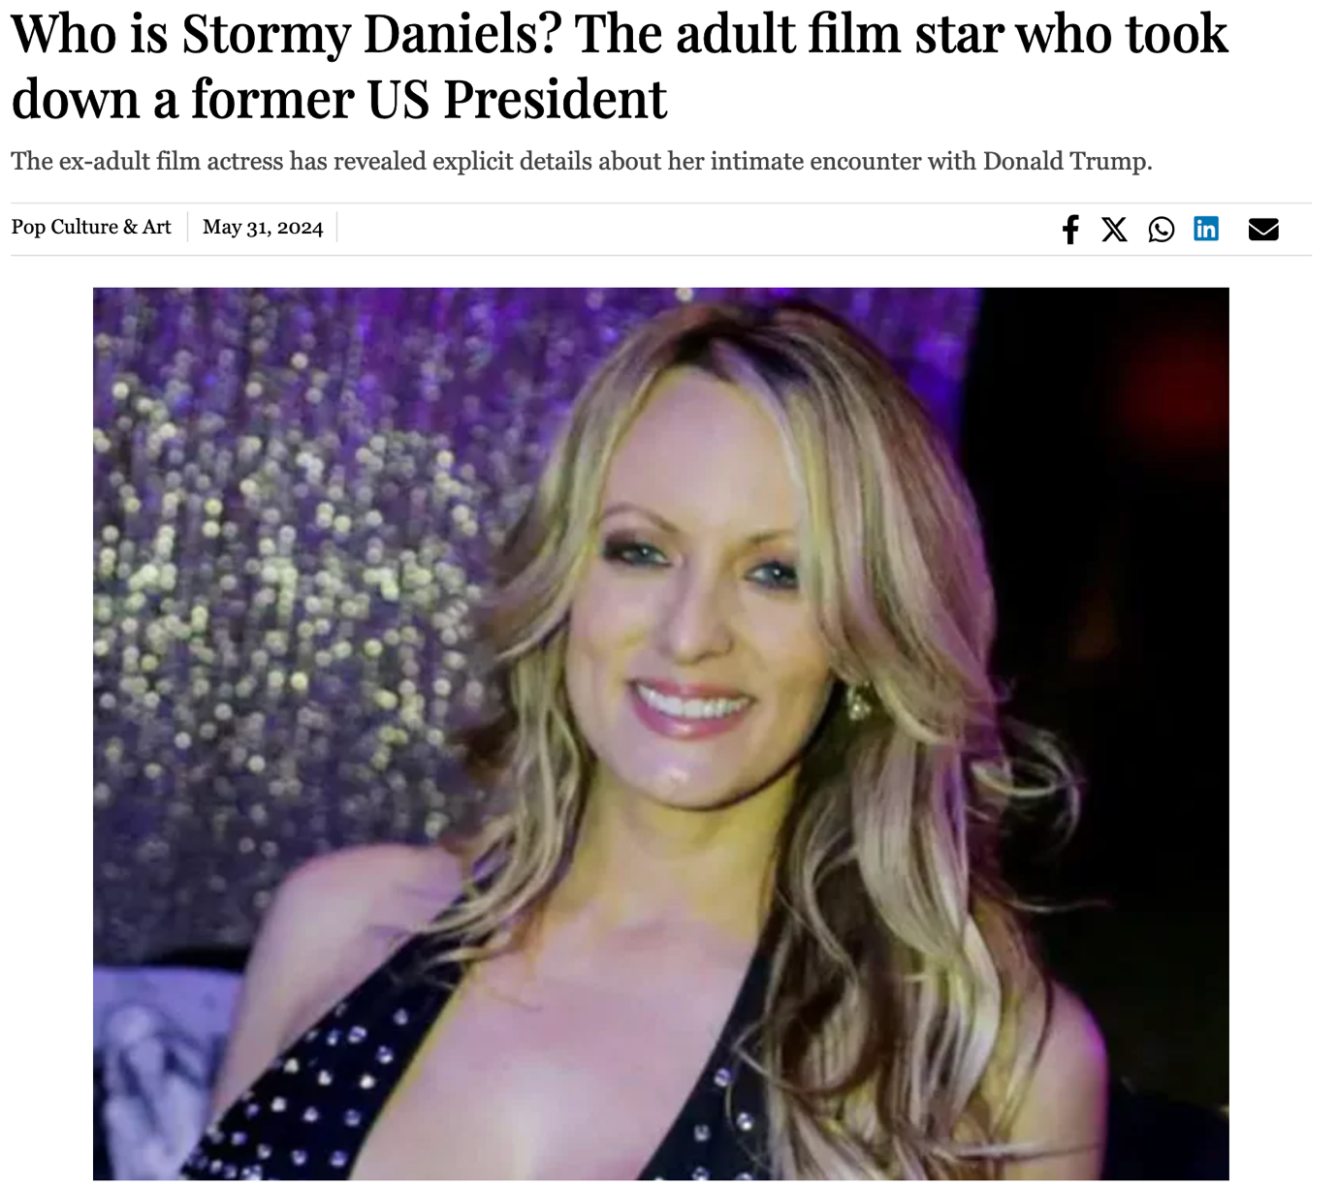

1. Netflix co-founder Reed Hastings urges Biden to step down from 2024 Election (<https://tribune.com.pk/story/2476933/netflix-co-founder-reed-hastings-urges-biden-to-step-down-from-2024-election>)

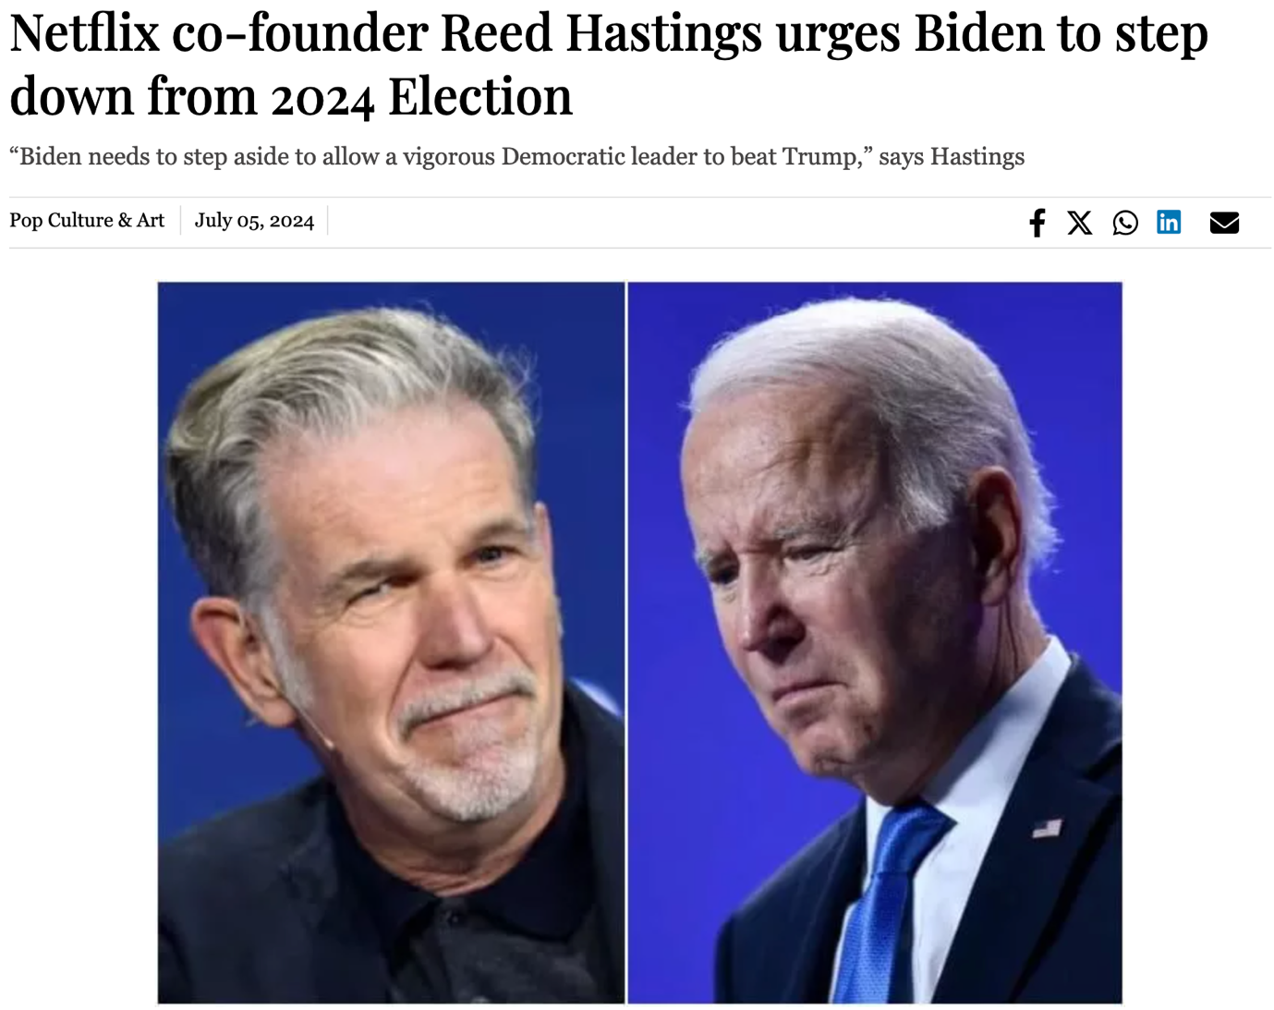

1. Here are all the celebrities sitting courtside at Wimbledon 2024 (<https://tribune.com.pk/story/2476280/here-are-all-the-celebrities-sitting-courtside-at-wimbledon-2024>)

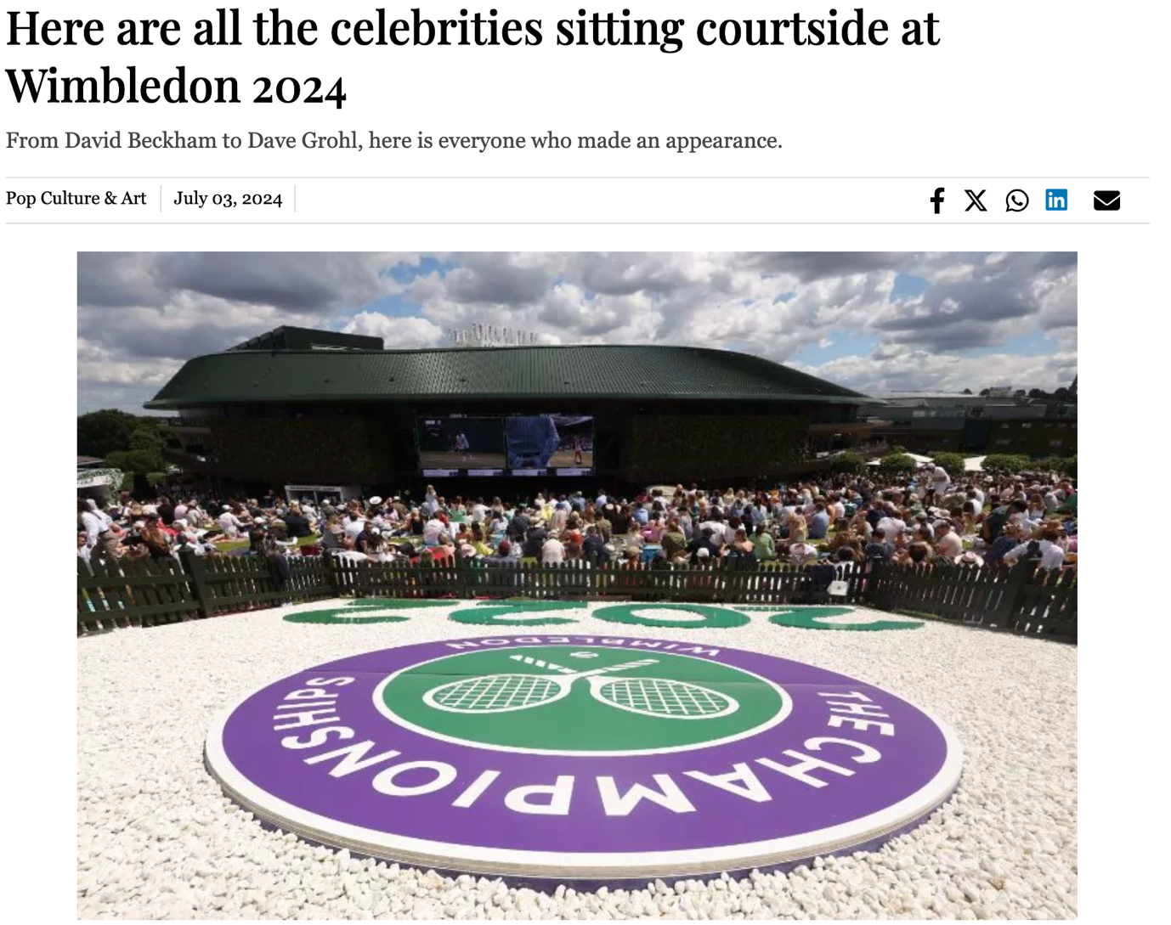

1. Neil Gaiman faces multiple allegations of sexual assault; author responds (<https://tribune.com.pk/story/2476486/neil-gaiman-faces-multiple-allegations-of-sexual-assault-author-responds>)

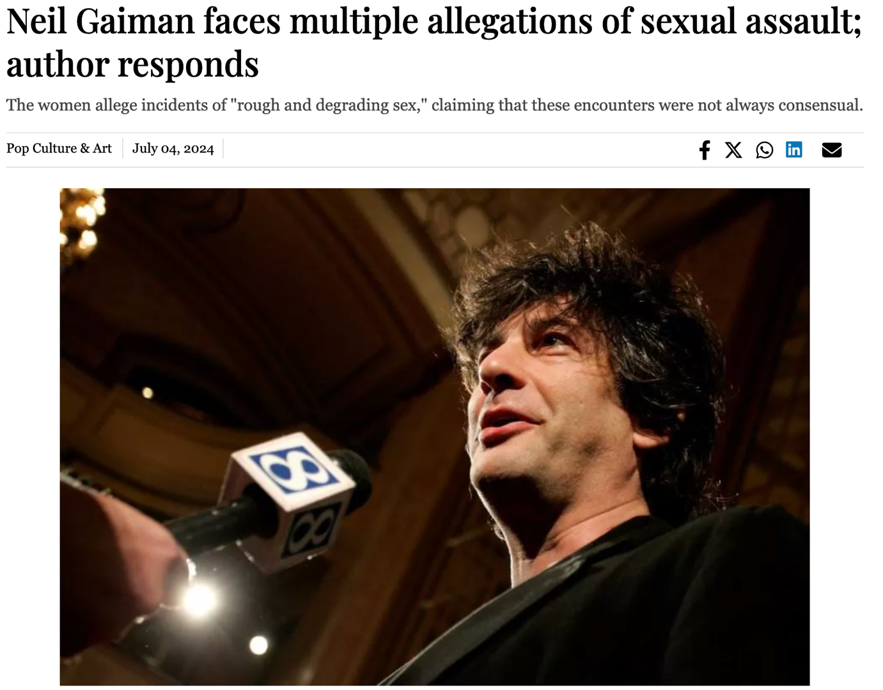

1. BTS’ Kim Seok-jin has returned from military service (<https://tribune.com.pk/story/2471194/bts-kim-seok-jin-has-returned-from-military-service>)

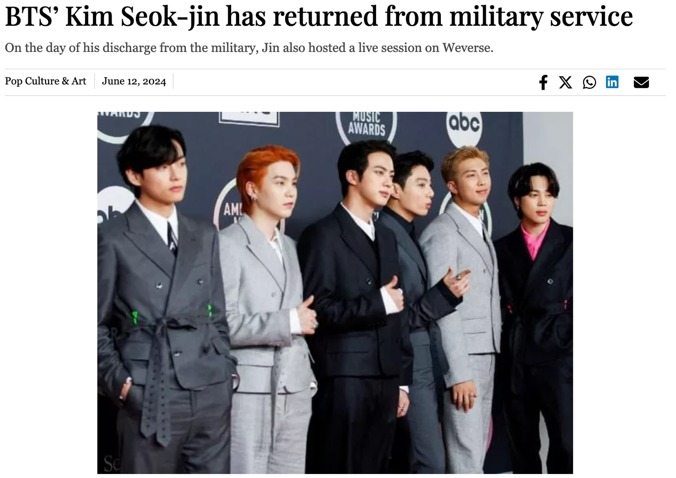

1. Simone Biles and Team USA win historic gold in women’s gymnastics at Paris Olympics (<https://tribune.com.pk/story/2484442/simone-biles-and-team-usa-win-historic-gold-in-womens-gymnastics-at-paris-olympics>)

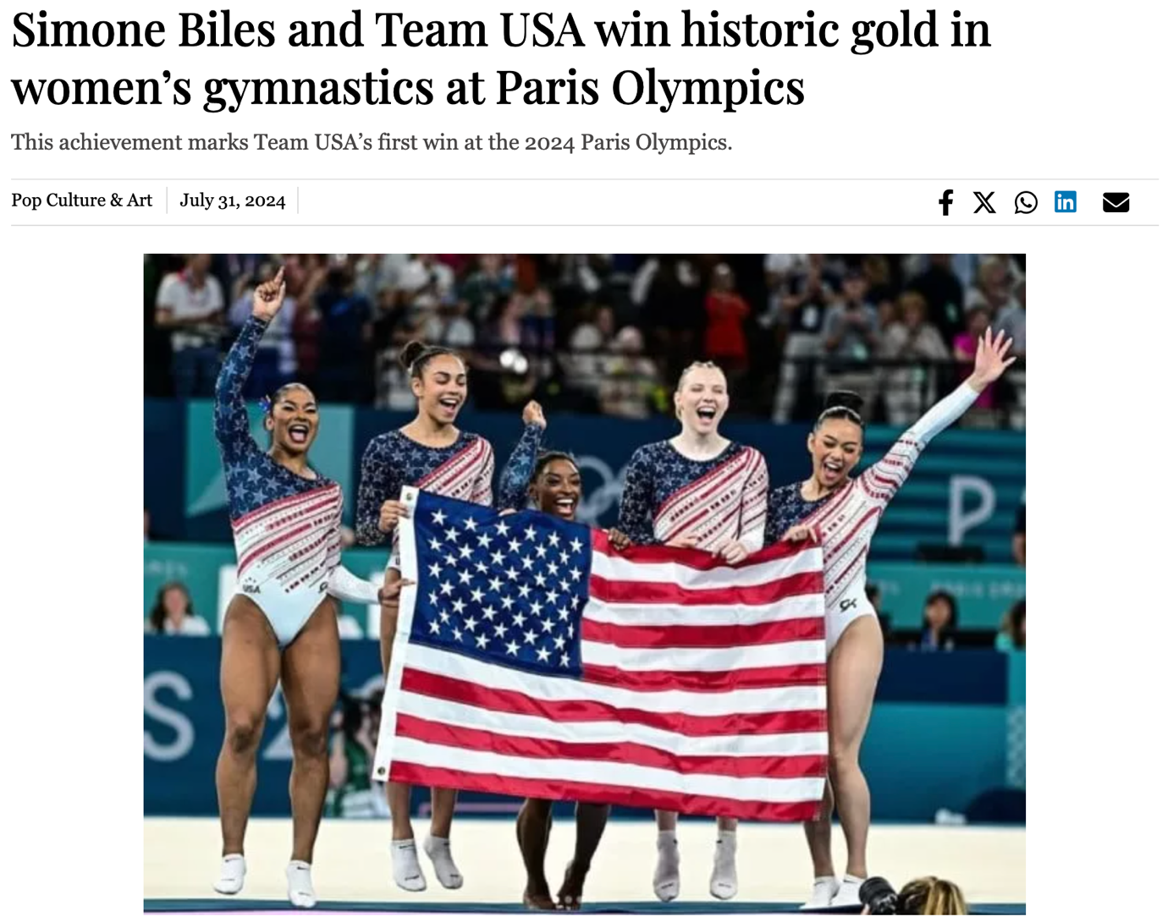

1. Fans criticize Angela Carini's apology to Imane Khelif amidst Paris Olympics controversy (<https://tribune.com.pk/story/2485054/fans-criticize-angela-carinis-apology-to-imane-khelif-amidst-paris-olympics-controversy>)

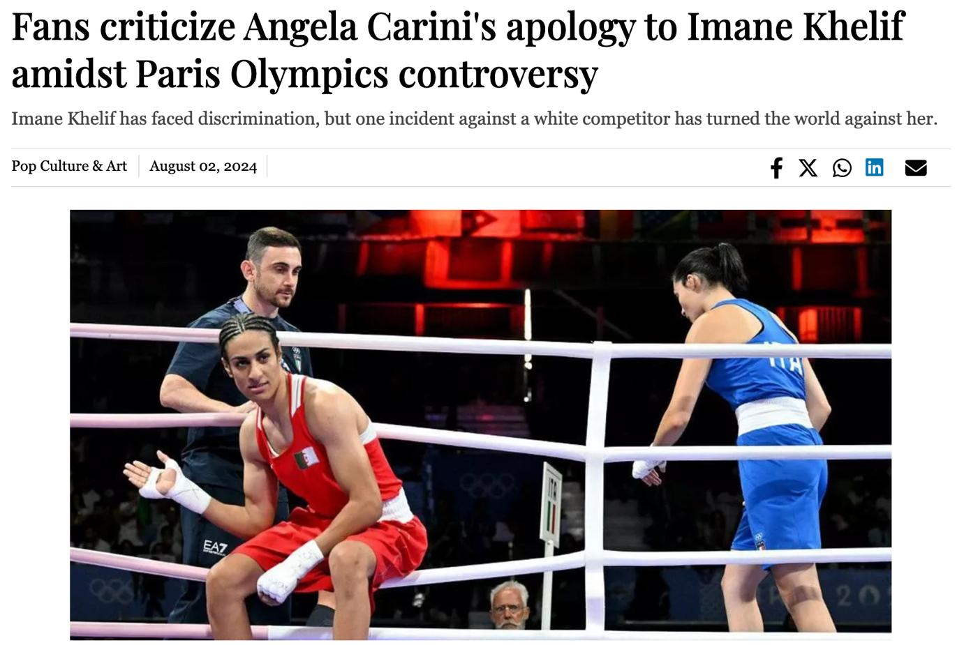

1. WWE Recap: Roman Reigns returns to SummerSlam 2024, Drew McIntyre scores big win (<https://tribune.com.pk/story/2485469/wwe-recap-roman-reigns-returns-to-summerslam-2024-drew-mcintyre-scores-big-win>)

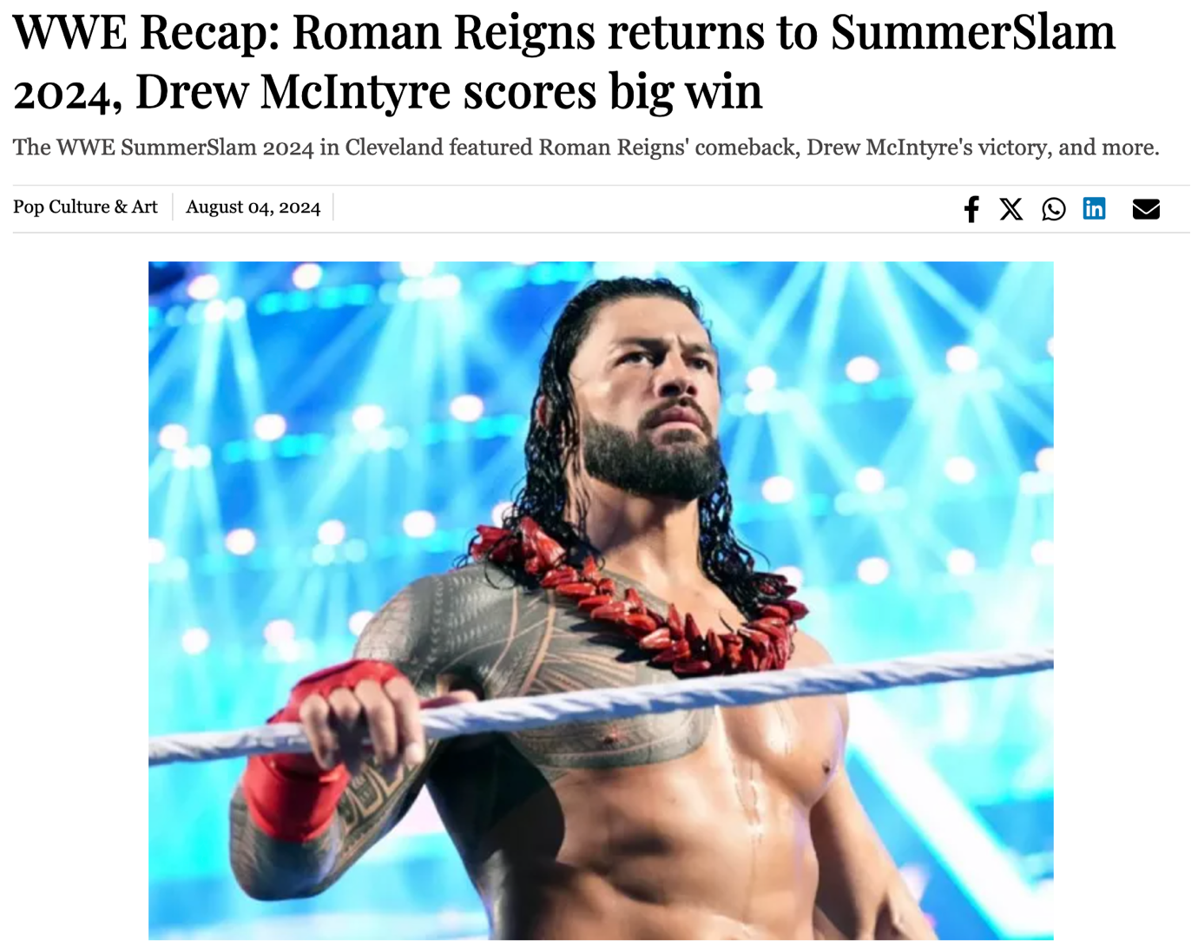

1. Team USA’s Noah Lyles responds to criticism over painted nails (<https://tribune.com.pk/story/2485699/team-usas-noah-lyles-responds-to-criticism-over-painted-nails>)

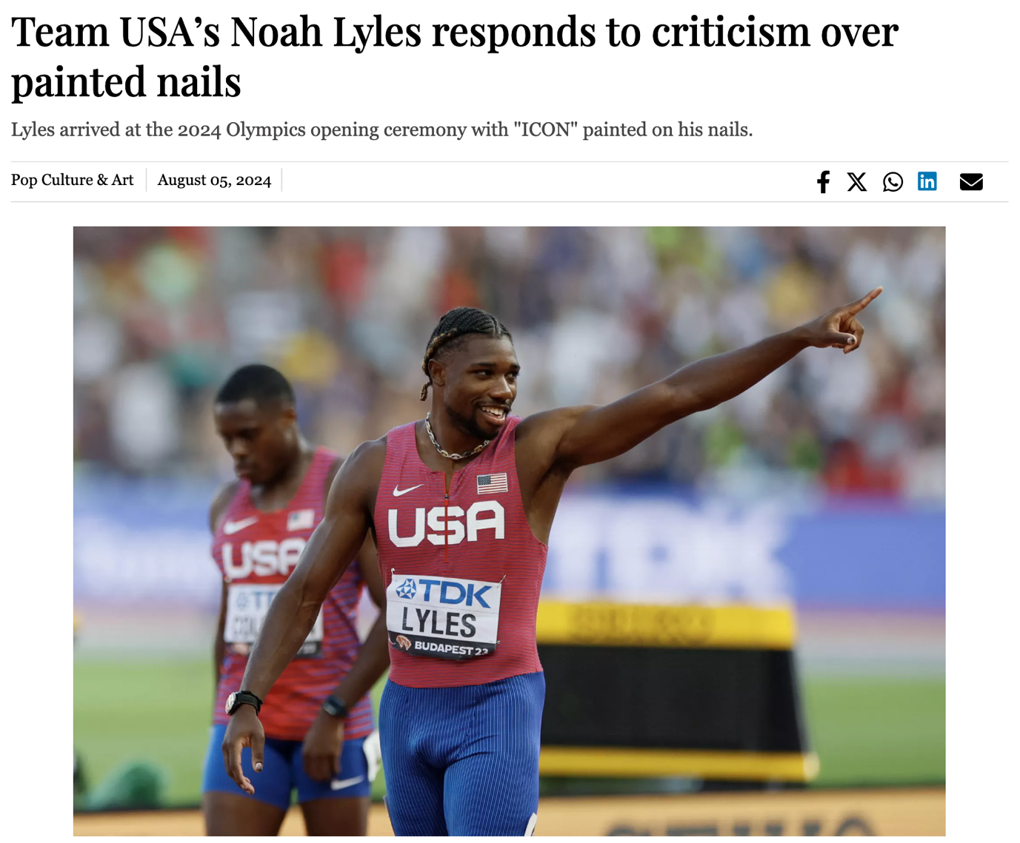

1. Gold medalist Thomas Ceccon found sleeping in park, complains about Olympic Village conditions (<https://tribune.com.pk/story/2485751/gold-medalist-thomas-ceccon-found-sleeping-in-park-complains-about-olympic-village-conditions>)

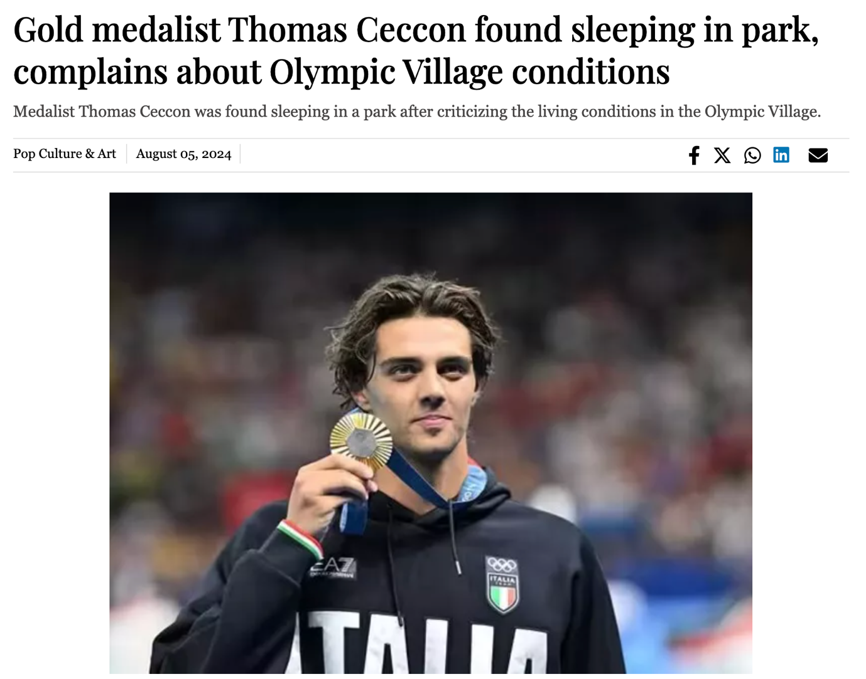

1. Justin Bieber earns $10 million for performing at Mukesh Ambani's son's wedding (<https://tribune.com.pk/story/2477140/justin-bieber-earns-10-million-for-performing-at-mukesh-ambanis-sons-wedding>)

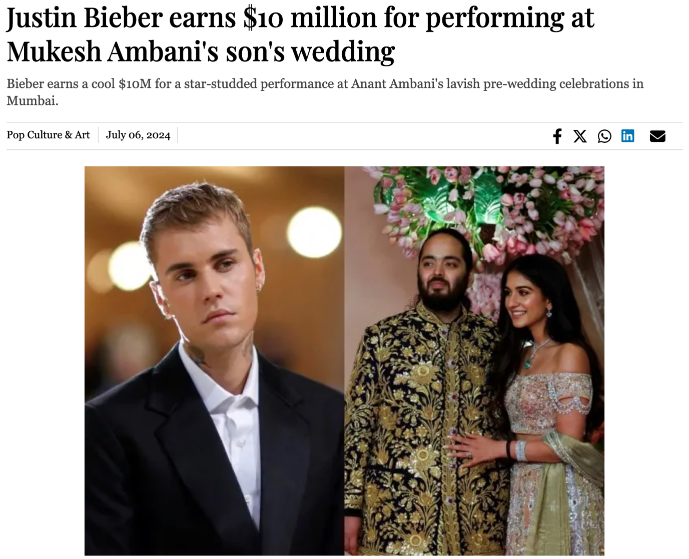

1. Inside Shelley Duvall’s struggles with mental illness: Dr. Phil, The Shining and Stanley Kubrick (<https://tribune.com.pk/story/2479074/inside-shelley-duvalls-struggles-with-mental-illness-dr-phil-the-shining-and-stanley-kubrick>)

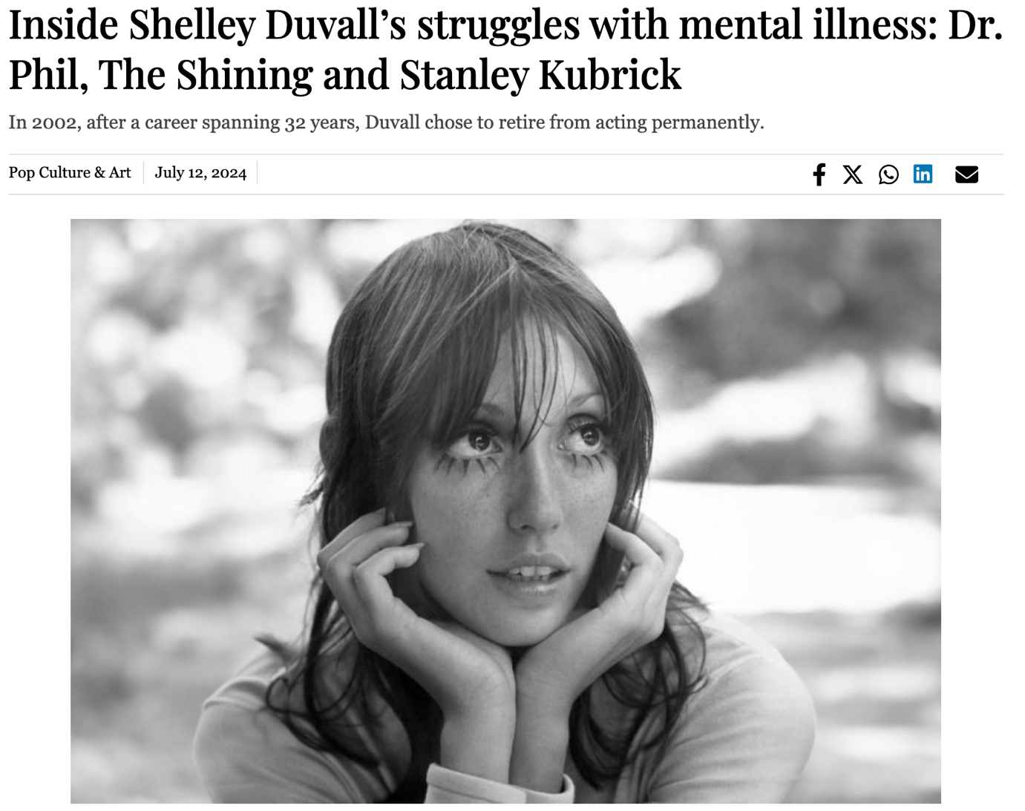

1. Biden mistakes Volodymyr Zelenskyy for Vladimir Putin, raising concerns about his mental capacity (<https://tribune.com.pk/story/2479110/biden-mistakes-volodymyr-zelenskyy-for-vladimir-putin-raising-concerns-about-his-mental-capacity>)

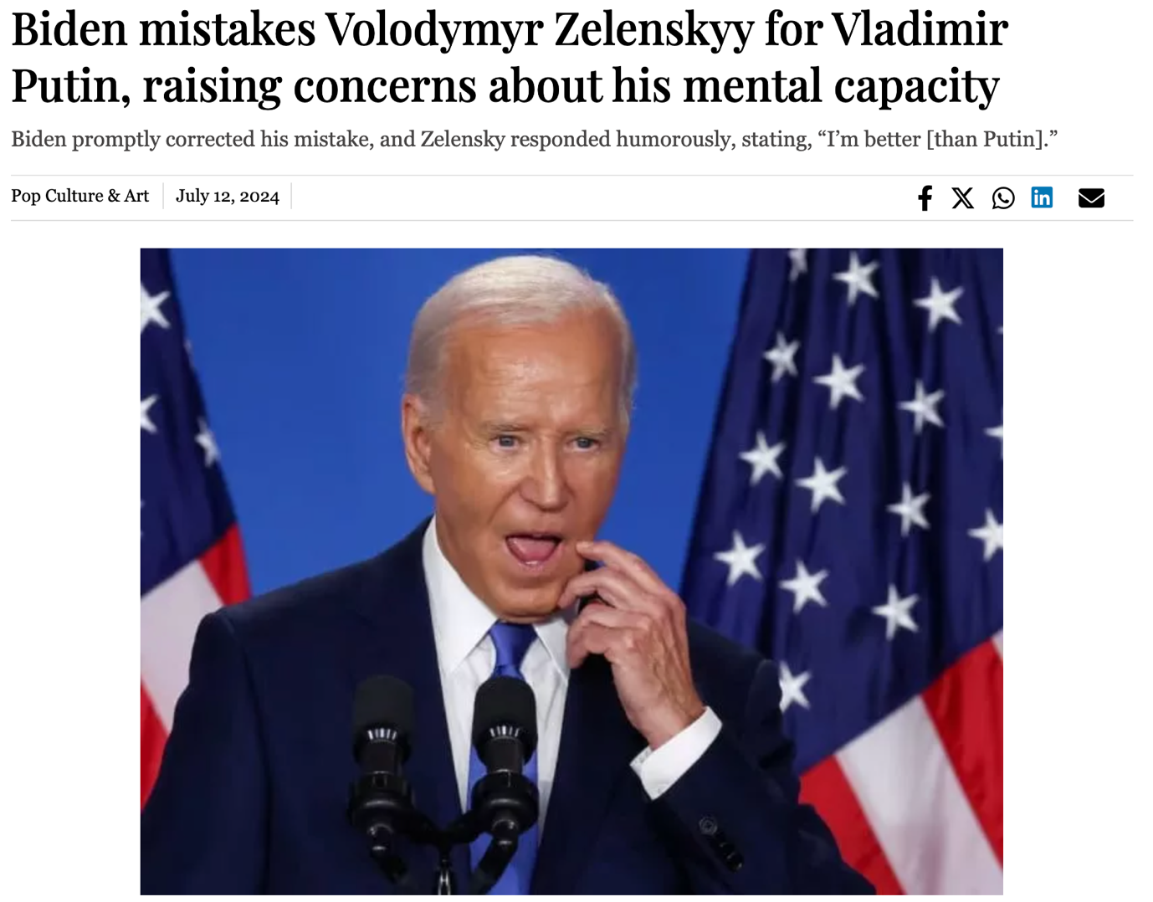

1. Euro 2024: Prince William praises England team despite loss to Spain (<https://tribune.com.pk/story/2479879/euro-2024-prince-william-praises-england-team-despite-loss-to-spain>)

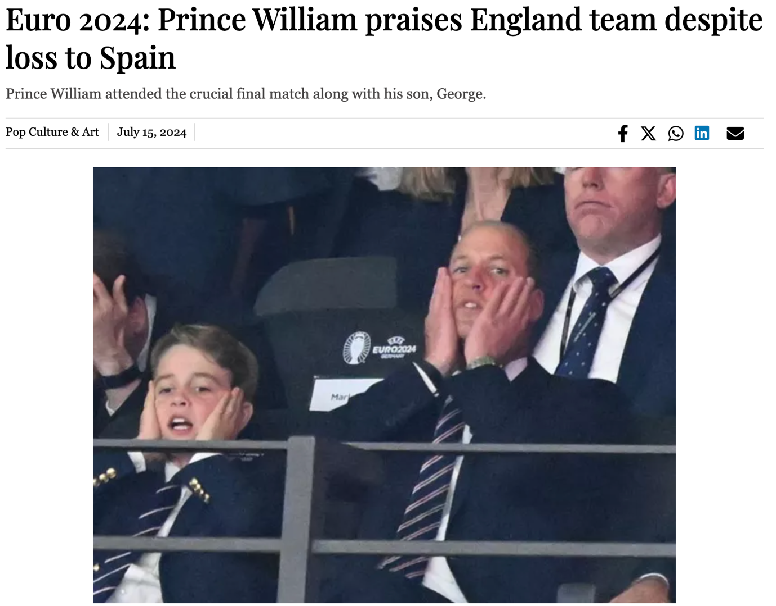

1. Shakira’s $2 million halftime performance at Copa America 2024 final: "I guess Pique won’t be there” (<https://tribune.com.pk/story/2479874/shakiras-2-million-halftime-performance-at-copa-america-2024-final-i-guess-pique-wont-be-there>)

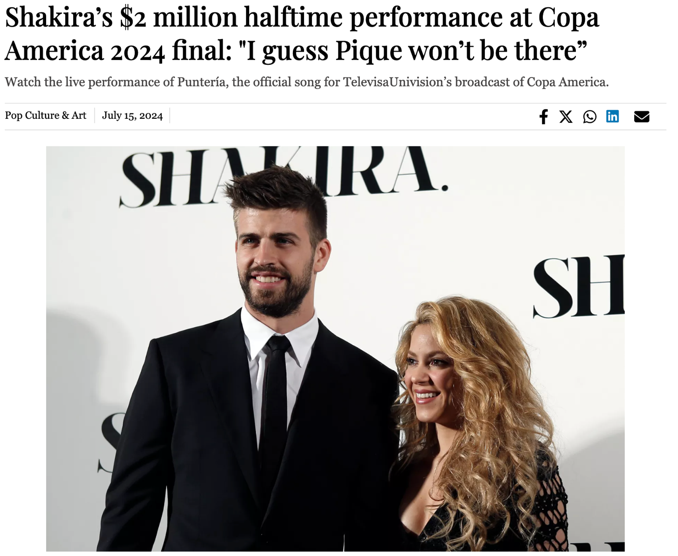

1. Harry Kane opens up about England losing Euro 2024 to Spain: “as painful as it can be” (<https://tribune.com.pk/story/2479934/harry-kane-opens-up-about-england-losing-euro-2024-to-spain-as-painful-as-it-can-be>)

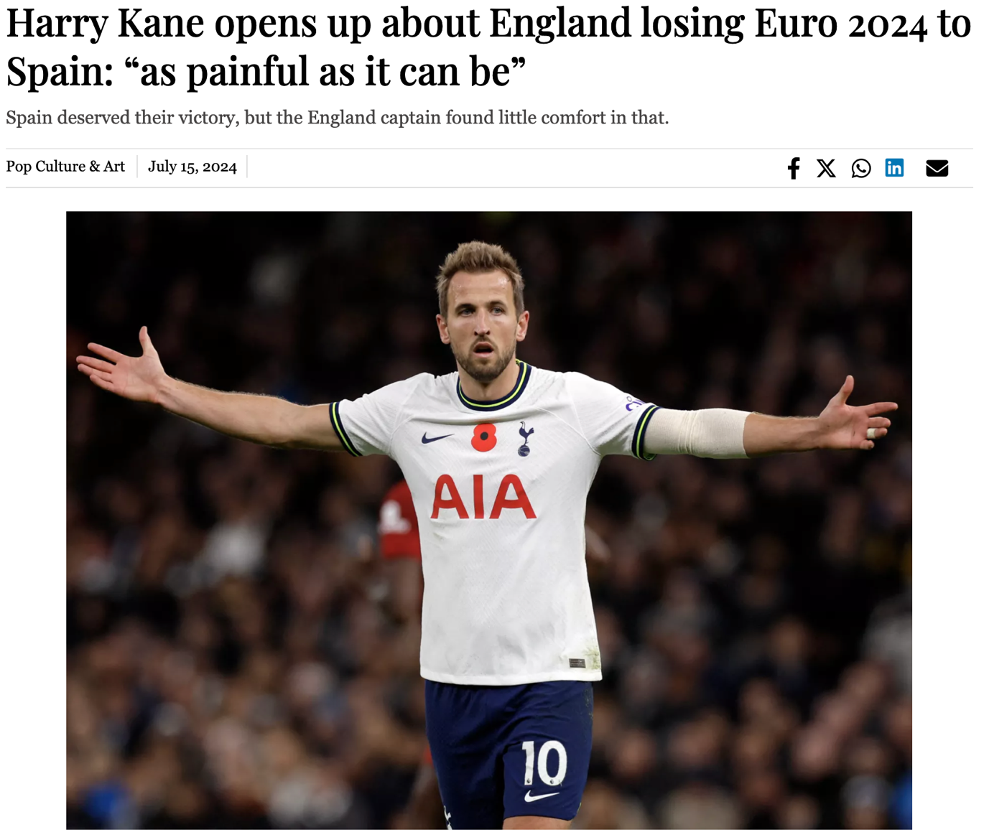

1. Donald Trump confirms that a chunk of his ear is gone (<https://tribune.com.pk/story/2480001/donald-trump-confirms-that-a-chunk-of-his-ear-is-gone>)

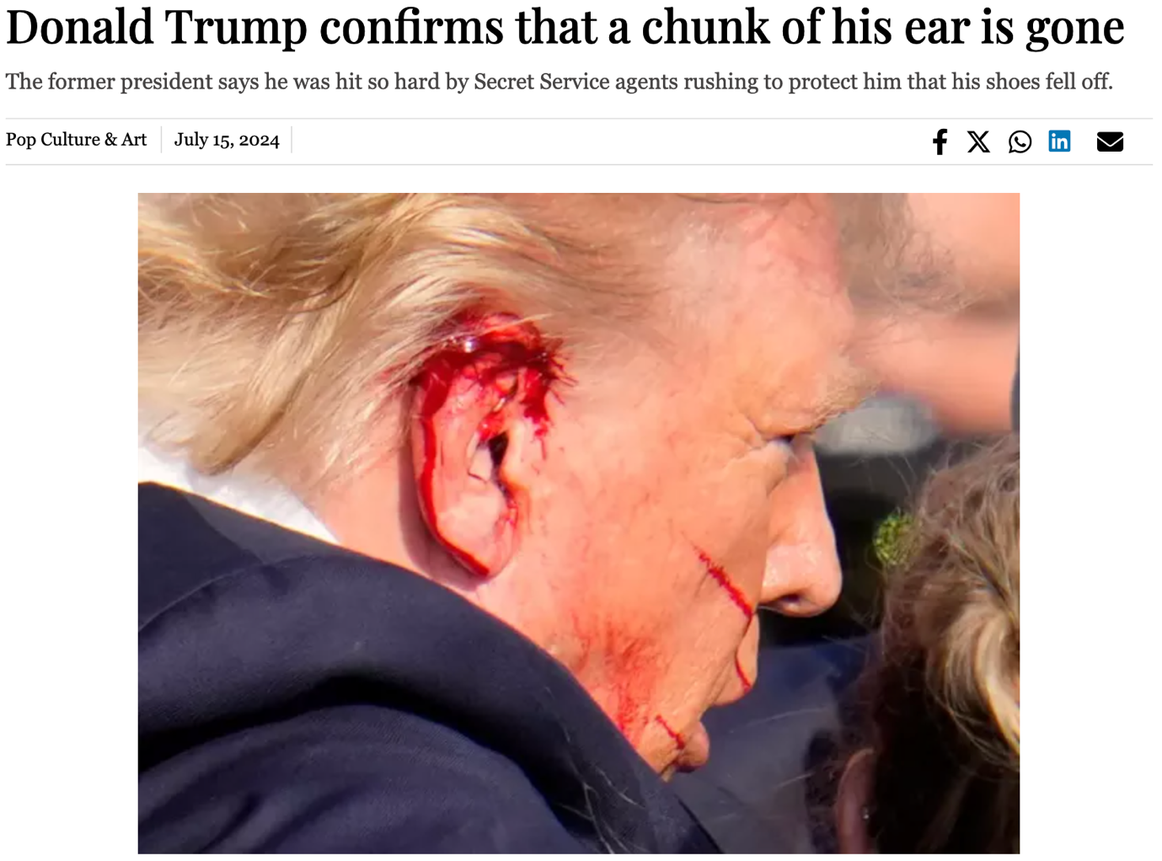

1. Big Brother Season 26 premieres with AI twist and 17th houseguest vote (<https://tribune.com.pk/story/2480164/big-brother-season-26-premieres-with-ai-twist-and-17th-houseguest-vote>)

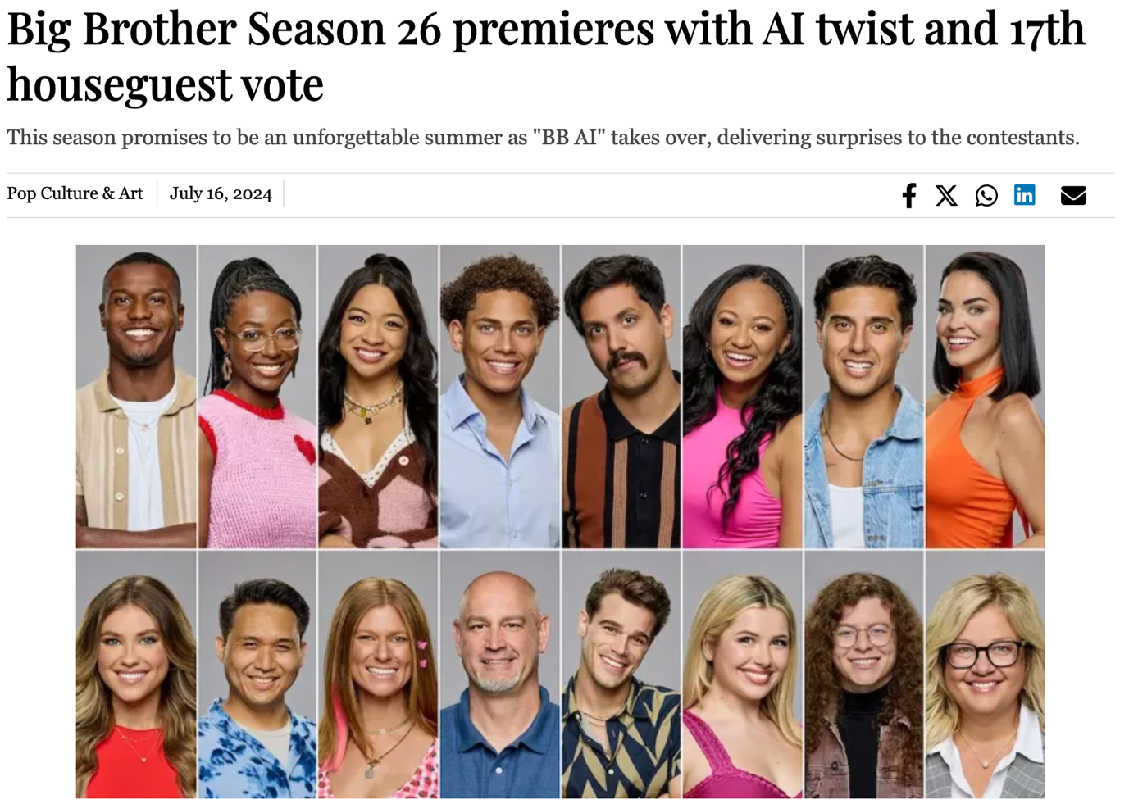

1. Shawn Mendes and Camila Cabello spark reconciliation rumours after Copa América sighting (<https://tribune.com.pk/story/2480162/shawn-mendes-and-camila-cabello-spark-reconciliation-rumours-after-copa-america-sighting>)

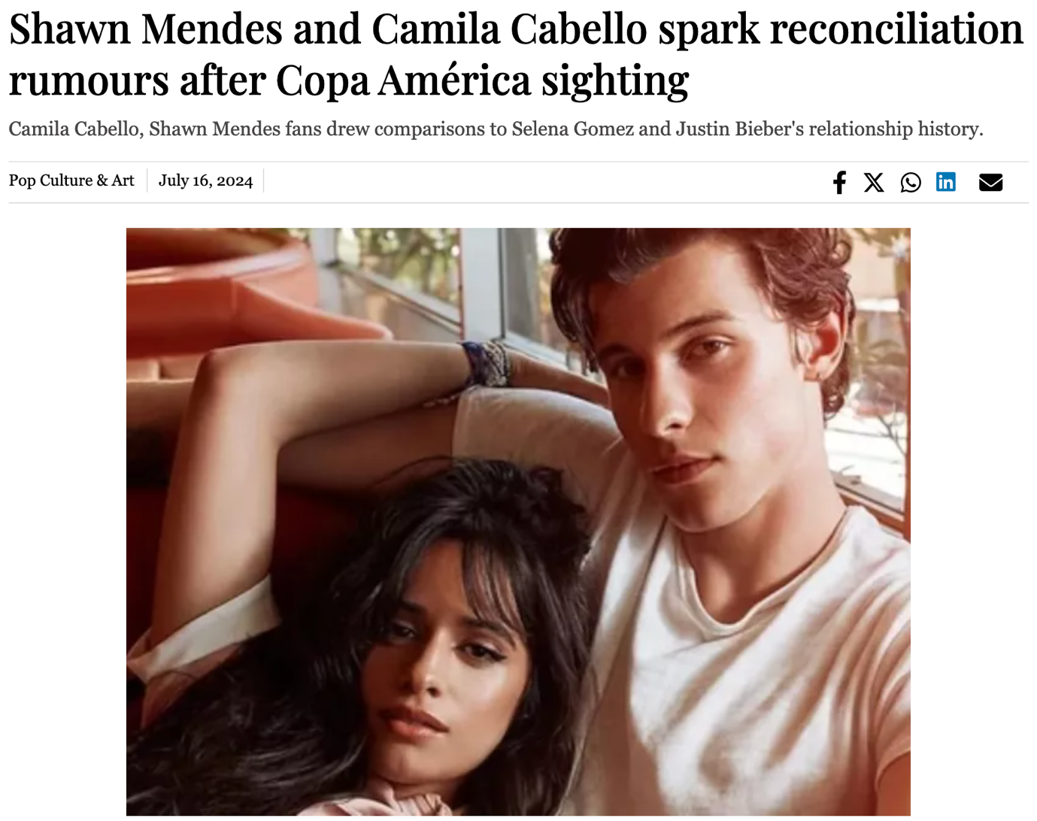

1. Elon Musk commits millions to electing Donald Trump (<https://tribune.com.pk/story/2480282/elon-musk-commits-millions-to-electing-donald-trump>)

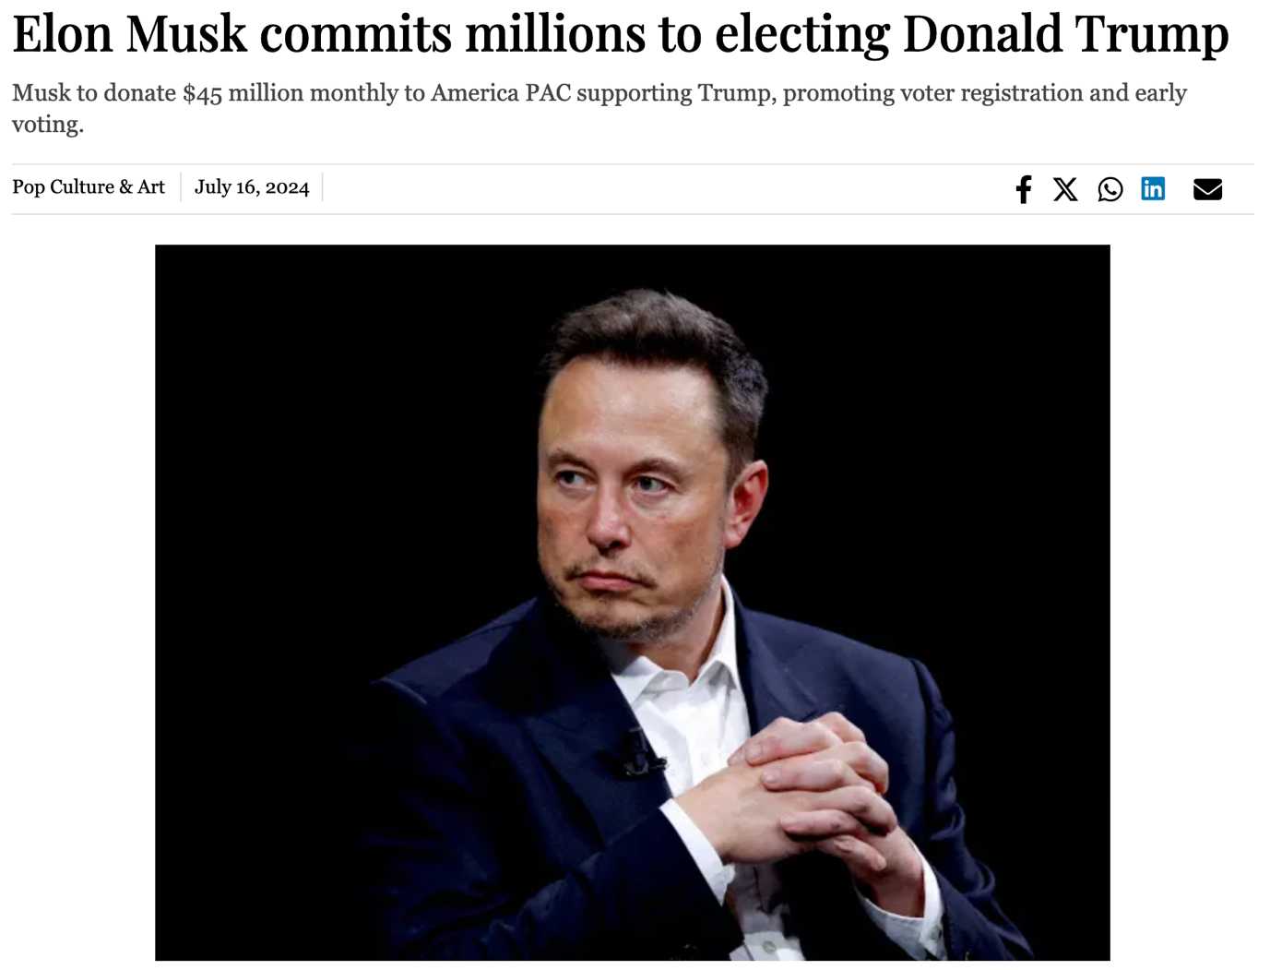

1. Stephen A. declares Donald Trump 2024 election winner after assassination attempt (<https://tribune.com.pk/story/2480278/stephen-a-declares-donald-trump-2024-election-winner-after-assassination-attempt>)

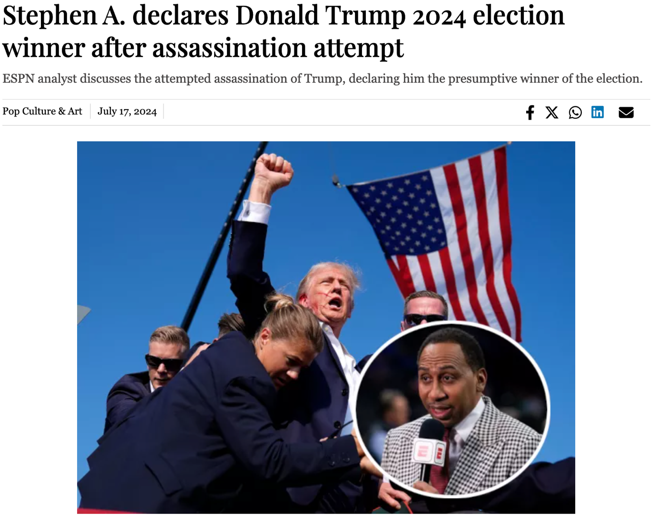

1. Queen Camilla honors Princess Diana with iconic Lady Dior bag at Wimbledon (<https://tribune.com.pk/story/2480505/queen-camilla-honors-princess-diana-with-iconic-lady-dior-bag-at-wimbledon>)

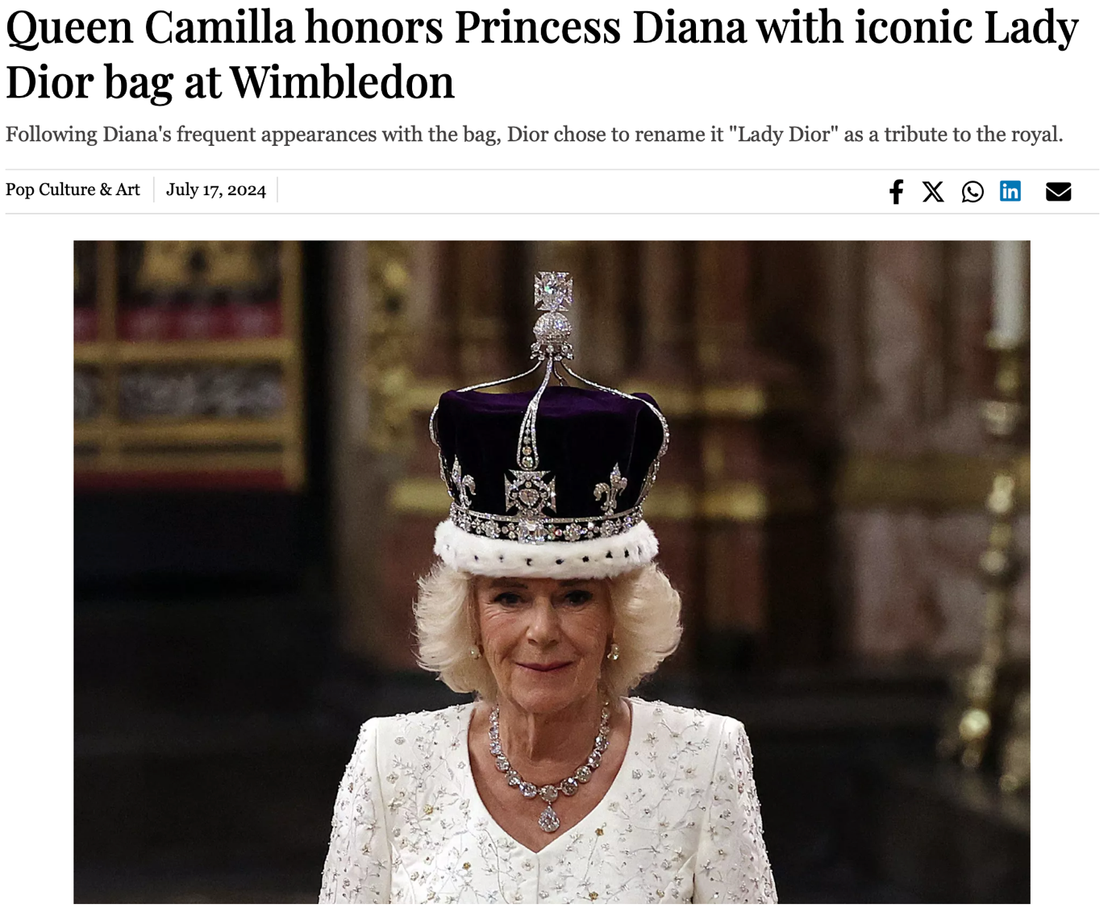

1. Kamala Harris adopts Charli XCX’s Brat and Kamala HQ branding to become the "Cool Girl" candidate (<https://tribune.com.pk/story/2482130/kamala-harris-adopts-charli-xcxs-brat-and-kamala-hq-branding-to-become-the-cool-girl-candidate>)

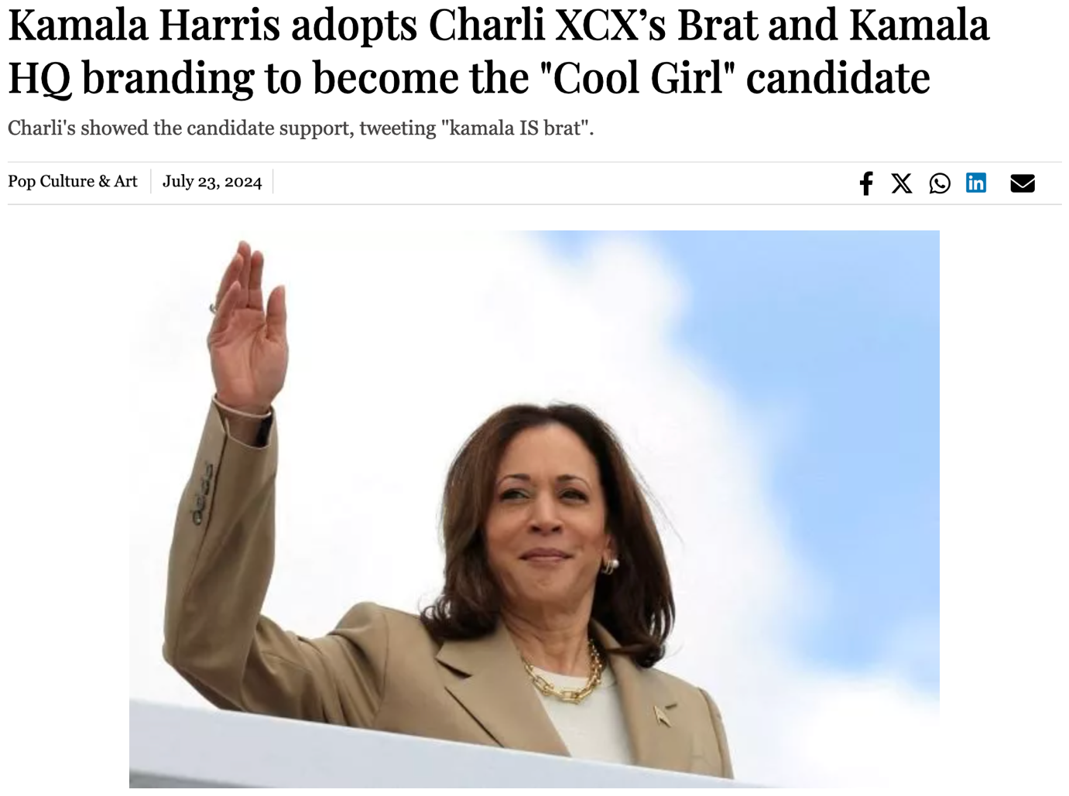

1. Madeline Argy and Brooke Schofield ask Central Cee and Clinton Kane: "Who TF Did I Marry?" (<https://tribune.com.pk/story/2482222/madeline-argy-and-brooke-schofield-ask-central-cee-and-clinton-kane-who-tf-did-i-marry>)

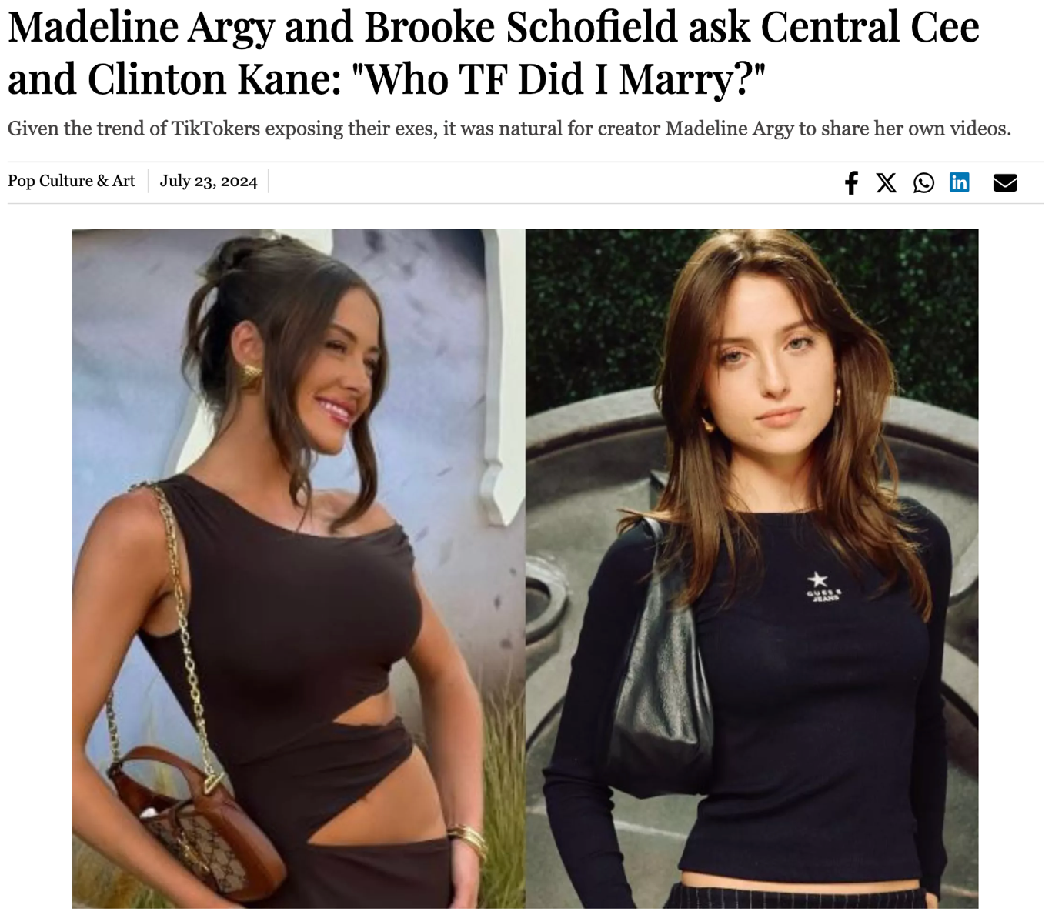

Contact Me Page

**Simple Contact Form which goes to my inbox (bismahtapal9@gmail.com):**

* **Name**
* **Email**
* **Message**

**Alternative:**

* **Email: bismahtapal9@gmail.com**